Activity 10.1

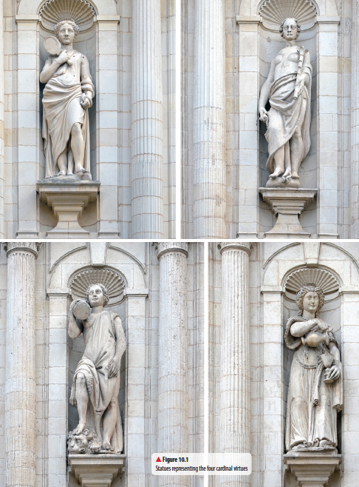
▲Figure 10.1 Statues representing the four cardinal virtues
1 Using a Venn diagram for each virtue, compare and contrast the various images in Figure 10.1 and how they represent the virtues. Consider if and how the various symbols are represented in the images. You may wish to include other images.
▲ Figure 10.2 Crest showing symbols of the four cardinal virtues
Table1.1
Virtue | Prudence | Justice | Fortitude | Temperance
Traditional symbols

Symbol

Justification

2 Using your understanding of the four cardinal virtues, create modern symbols that could be used on digital applications such as an icon added to a text message.

3 Identify four modern characters, either from fiction or film, which represent the four cardinal virtues. Combining your understanding of the characters in the context of their narratives with the traditional symbols of each virtue, create a hand-held item each character could carry to represent their virtue.

4 Moviemakers have decided to use the four cardinal virtues as the basis of the super-hero Batman’s character, in the soon-to-be released movie. You and your team have been assigned with the task of developing the marketing campaign, including the posters and movie trailer. Your task is to launch the marketing campaign and explain the links between Batman’s character and the cardinal virtues and the reasons they work successfully in the film.
You can do this by creating either a poster or a movie trailer using Voki (do a search for Voki on the internet).

5 Imagine your home city is hosting the next Commonwealth Games and your school has won the opportunity to participate in the opening ceremony.
The Organising Committee has decided that the cardinal virtues will be the theme for the Games.
a Write the opening speech that clearly links the cardinal virtues with the aspirations of great sportspeople.

b Create an emblem or logo that incorporates sporting endeavours with the cardinal virtues.

6 In chapter 7 of J. K. Rowling’s Harry Potter and the Philosopher’s Stone, the Sorting Hat sings a song that depicts the virtues of each house. Read the lyrics to the song:
There’s nothing hidden in your head
The Sorting Hat can’t see,
So try me on and I will tell you
Where you ought to be.

You might belong in Gryffindor,
Where dwell the brave at heart,
Their daring, nerve, and chivalry
Set Gryffindors apart;

You might belong in Hufflepuff,
Where they are just and loyal,
Those patient Hufflepuffs are true
And unafraid of toil;

Or yet in wise old Ravenclaw,
If you’ve a ready mind,
Where those of wit and learning,
Will always find their kind;

Or perhaps in Slytherin
You’ll make your real friends,
Those cunning folks use any means
To achieve their ends.

– J. K. Rowling (1997),
Harry Potter and the Philosopher’s Stone, p. 88

Try to match the cardinal virtues to each house. Is there a house that does not match a virtue in the song? If not, how and why not?

