Chapter 1: Measuring health status
Activity sheet 1 – Matching terms
Match each of the following terms with its definition.
Term | Definition
Burden of disease | A count of how many new cases of a particular disease or illness have occurred during a specific reporting period.
HALE | The numbers of deaths caused by a particular disease, illness or other environmental factor.
Incidence | The impact, prevalence and incidence of disease in a particular group of people.
DALYs | The rate at which a particular disease or illness occurs.
Mortality | A calculation of how many years an individual is expected to live in full health and without illness, disability or premature death.
Life expectancy | The number of years of life lost due to infirmity, disability or premature mortality.
Prevalence | A count of how many people currently have a particular disease or illness.
Morbidity | An estimate of the total number of years, from the time of birth, that an individual is expected to live.

Answers
Term | Definition
Burden of disease | The impact, prevalence and incidence of disease in a particular group of people.
HALE | A calculation of how many years an individual is expected to live in full health and without illness, disability or premature death.
Incidence | A count of how many new cases of a particular disease or illness have occurred during a specific reporting period.
DALYs | The number of years of life lost due to infirmity, disability or premature mortality.
Mortality | The numbers of deaths caused by a particular disease, illness or other environmental factor.
Life expectancy | An estimate of the total number of years, from the time of birth, that an individual is expected to live.
Prevalence | A count of how many people currently have a particular disease or illness.
Morbidity | The rate at which a particular disease or illness occurs.

Chapter 1: Measuring health status
Activity sheet 2 – Media analysis
Life expectancy to drop for first time in 1000 years
By Jacqueline Maley and Mark Todd / Courtesy of Fairfax
Australians could be eating themselves to an early death, with new research suggesting life expectancy will decline for the first time in 1000 years due to the obesity epidemic.
A paper published in the New England Journal of Medicine predicts a decrease in life expectancy, which rose slowly but steadily last millennium. Experts say Australia will mirror the trend. The drop will occur when the current generation of obese and overweight adults reaches old age, and will worsen when obese and overweight children hit middle age.
‘It is distinctly possible that our children may live shorter lives than us. It’s a frightening prospect,’ study author Professor Jay Olshansky said yesterday in Brisbane, where he attended the second International Conference on Healthy Ageing and Longevity.
‘It would be the first time in the modern era we would actually see one generation experiencing a shorter life span than the previous generation.’
Professor Olshansky likens obesity to a ‘threatening storm’, which will have a drastic effect on longevity if left unchecked.
According to his research, the decline in life expectancy will occur in the first half of this century. To start with, life spans will shorten by four to eight months.
In coming decades, as obese children carry their elevated risks of death and disease into older age, average lifespans could fall by two to five years.
Obesity has been shown to reduce the length of life by about five to 20 years. About 68% of Australian men and 52% of Australian women are overweight or obese, which puts them at an elevated risk of Type 2 diabetes, heart disease and cancer.
Source: The Sydney Morning Herald, 18 March 2005
Questions
1 Which factors influencing health status are likely to be responsible for the decline in life expectancy, as described in the article? Name and give an example of each.

2 What are the potential consequences of this disturbing trend:
a For the individual?

b For the community?

c For governments?

3 Develop and outline one health promotion strategy that you believe might go at least some way towards addressing the issue today.

Chapter 2: The health status of Australians
Activity sheet 1 – Research task and oral presentation
1 In small groups, research difference in health experienced by the following population groups:
- males vs. females
- Indigenous vs. non-Indigenous
- rural and remote vs. metropolitan
- higher socioeconomic vs. lower socioeconomic

2 Prepare a brief handout, PowerPoint presentation, brochure or poster that includes the following information about your population groups:
- differences in leading causes of disease burden
- differences in leading causes of mortality
- differences in life expectancy rates
- comparison of any inequalities in health status with the total population
- major risk factors influencing the health status of your selected population group.
Within your presentation, use the most current statistical data possible to support the information you have included.
3 Present your information to the rest of your class.
Chapter 2: The health status of Australians
Activity sheet 2 – Media analysis
Men losing the battle
By Fay Burstin / Courtesy of the Herald and Weekly Times
When it comes to health, the battle of the sexes looks more like a walk-over than a fair contest. On average, men die younger than women and face twice the risk of heart disease and most cancers. Blokes are four times more likely to commit suicide, three times more likely to die in road accidents or violence and their injury rates outstrip women’s by more than three to one.
Although men are usually physically stronger, they’re clearly not always healthier. So what’s wrong with our boys?
Women may have a biological advantage with female hormones helping protect against heart disease until menopause, but men typically take more risks. They’re more likely to work in dangerous jobs, explaining why men account for more than 90% of victims of work-related deaths. But often men take unnecessary risks – from careless driving to high-risk sports.
Fellas generally don’t care as much about their health. They’re more likely to smoke, drink too much alcohol and not protect their skin from the sun. And while some men may exercise more, they certainly don’t pay attention to their diet in the same way women do. If you’re male, chances are you eat less fruit and vegetables, more meat (but less likely to trim off the fat), more fast food, sweets and cakes. And despite their poorer health overall, men are less likely to see a doctor – often until it’s too late.
But Dr Gavin Lambert, from the Baker Heart Research Institute, suggests the figures don’t necessarily tell the whole truth. More men might be overweight, but more women were obese, he said. Women might go to the doctor more often, he said, but there were more female hypochondriacs. ‘Men may have a far higher suicide rate, for example, but women tend to be more para-suicidal and make more unsuccessful attempts,’ Dr Lambert said.

THE COMPARISON
LONGEVITY  - Women live an average five years longer than men  - Widows tend to live much longer than widowers  - Boys’ death rate after 12 months old is 35% higher than girls’  HEART DISEASE  - Men face twice the risk of heart disease and dying from it, but women are more likely to die of a sudden heart attack  - Men are more likely to have multiple risk factors like smoking, physical inactivity, overweight and diabetes  OBESITY  - Almost 50% of men are overweight compared with 30% of women  - But 28% of women are obese compared with 23% of men  CANCER  - Almost twice as many men die from cancer as women  - Twice as many men die from skin cancer and three times as many die from lung cancer | LUNG DISEASE  - More than twice as many men die from chronic obstructive pulmonary disease  - Men have a 25% greater chance of dying from influenza and pneumonia  DIABETES  - 8% of men have diabetes compared with 6.8% of women  DEMENTIA  - Women are slightly more likely to suffer from dementia  MENTAL ILLNESS  - Women have a higher incidence of anxiety and depression but men face double the risk of a substance abuse disorder  - Men are four times more likely to commit suicide but women are more likely to fail in their attempts  OSTEOPOROSIS  - Twice as many women suffer from osteoporosis
Source: The Herald Sun, 30 March 2004
Questions
1 Identify the statistics that are given in the article that support the statement: ‘Although men are usually physically stronger, they’re clearly not always healthier.’

2 Describe the advantages indicated in the article that result in females having better health than males.

3 Identify the behavioural risks that males take indicated in the article.

4 According to Dr Lambert ‘the figures don’t necessarily tell the whole truth’. Why is this the case?

5 Using the information in the article, complete the following table indicating as many examples of influences on the health of males as you can from the information provided. One example has been completed for you.
(Note: It is possible for an influence to be due to more than one determinant.)

Determinant influencing health | Example of influence | Possible impact on health
Lifestyle and behaviour | Men are more likely to smoke | - Higher risk of cardiovascular disease  - Higher rates of lung diseases and lung cancer

Chapter 3: Nutrition and health
Activity sheet 1 – Crossword
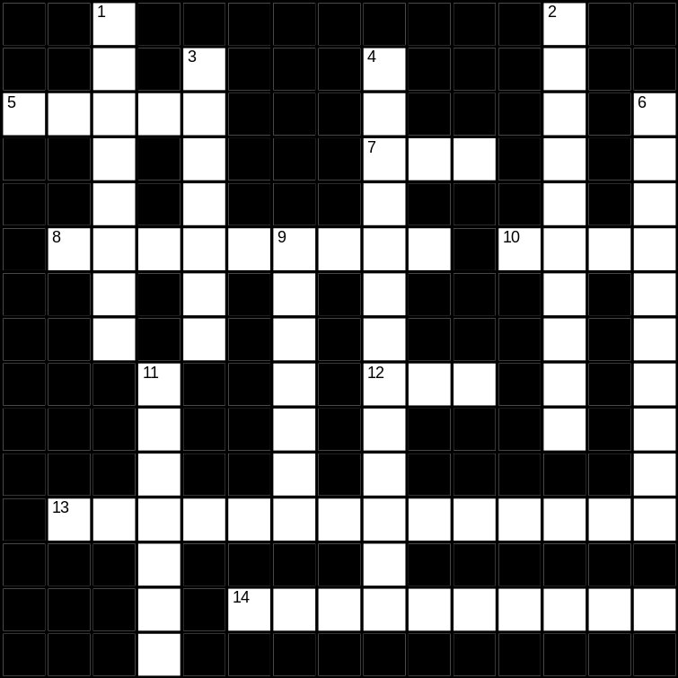
Across
5 Used by the body for many functions, including regulating temperature, removing waste products and transporting required substances (5 letters)
7 Recommended Dietary Intake (3 letters)
8 The chemical or mechanical breakdown of food (9 letters)
10 Provides 37 kilojoules of energy per gram (4 letters)
12 Folate is used by the body in the formation of this (3 letters)
13 Large molecules that are needed in large quantities by the body (14 letters)
14 Vitamins A, D, E and K are this (3, 7 letters)

Down
1 Nutrient found in green leafy vegetables (8 letters)
2 These foods are high in fibre (10 letters)
3 Digested in the small intestine (7 letters)
4 These should provide approximately 55% of daily energy needs (13 letters)
6 Second most abundant mineral found in the body (10 letters)
9 Coenzyme involved in the reaction resulting in energy release (7 letters)
11 Required for the formation and hardening of bones (7 letters)

Answers
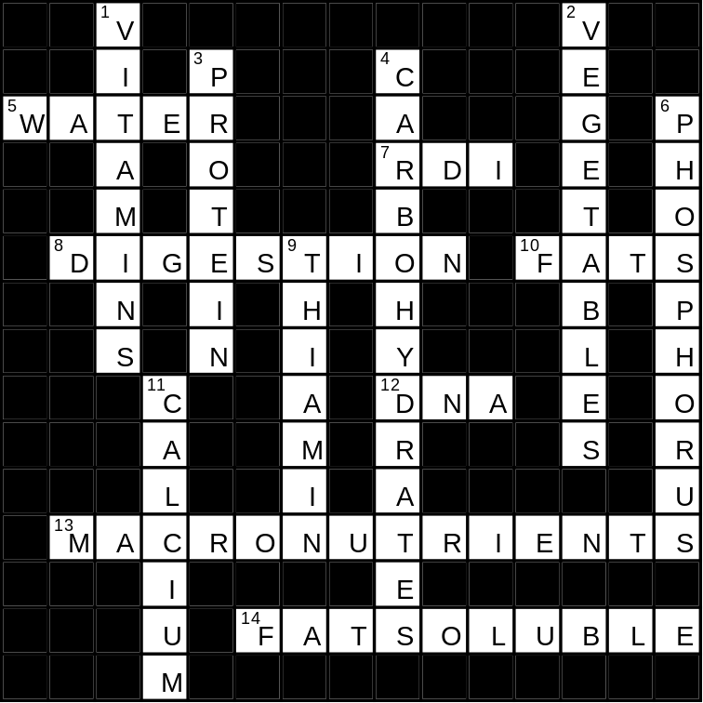
Chapter 3: Nutrition and health
Activity sheet 2 – Media analysis
Meal out a fat lot of good
By Catherine Lambert / Courtesy of the Herald and Weekly Times
Many Victorians are eating more than their daily energy requirement every time they eat in a restaurant or café. In a five-year survey of about 400 people, Melbourne nutritionist Shane Bilsborough has found that men are eating an average of 11 000 kilojoules when they eat out. The intake is as alarming for women, who are eating an average of 7400 kilojoules in one sitting.
‘It’s one of the scariest surveys I have ever done,’ Mr Bilsborough said. ‘It’s frightening to really look at how much people are eating. They feel stuffed and just think they’ve eaten a bit much, but in fact they’re trashing and gorging themselves. Worst of all, they’ll never get that back. A man would have to walk 55 000 steps to burn off that and that’s not going to happen.’
Mr Bilsborough began the survey to see what people ate when they dined out (whether in restaurants, cafés or food courts). Apart from finding that people tend to focus on value for money – so they eat and drink maximum volumes – he found they were unaware of their fat and energy intake, tending to under-report what they have eaten.
‘It’s common for people to order high-kilojoule foods like naan or spring rolls just while they’re ordering the rest of the meal,’ he said. ‘Also, they choose food that is classically “fast” because it requires little chewing and is eaten quickly. They tend to say they won’t return to a restaurant if they don’t leave feeling full. People, especially men, are eating and drinking to oblivion, but it’s not bingeing – it’s just normal eating. It’s passive over-consumption.’
Though women also over-eat, Mr Bilsborough said they are more likely to over-drink because it doesn’t make them feel as full. They pick at food, without realising it is laden with kilojoules.
Mr Bilsborough created healthy option menus for the people in the survey. They include beginning with fluid courses such as soup, limiting alcohol, and filling up on fibre-rich foods such as vegetables. ‘With 50 000 Australians dying of heart disease every year, this has to be one of the key reasons for the battle of the bulge,’ he said.
Source: The Herald Sun, 7 January 2007
Questions
1 What are the RDIs for kilojoules for adult males and for adult females?

2 Compare the intake of kilojoules for a meal eaten in a restaurant or café to the total kilojoules required for a day for both men and women.

3 What is BMI? How is it calculated?

4 What might the effect be on a person’s BMI if they regularly consumed the indicated kilojoules in meals eaten out of the home?

5 Identify the reasons given in the article for the high intake of kilojoules when eating out?

6 What do you think ‘passive over-consumption’ means?

7 Explain why over-consumption is of such concern.

8 Describe the healthy option menus indicated in the article.

Chapter 4: Diet-related diseases
Activity sheet 1 – Case study
Read the following case study and answer the questions below.
Katie is a 19-year-old female who is five months pregnant. She works full-time as a retail assistant in a clothing store and she walks daily as she is aware of the need for her to be physically fit in order to stay healthy. Katie often has takeaway foods for lunch as she works in a shopping centre where these foods are readily available.
Katie’s intake of major nutrients for three days is as below.
NUTRIENT | Protein | Iron | Calcium | Fats | Fibre | Folate | Vitamin C
Total quantity for the 3 days | 225g | 21mg | 3400mg | 128g | 16g | 690μg | 112mg
RDIs
Nutrients over-consumed
Nutrients under-consumed

1 Complete the table above.

2 Compare Katie’s intake to the RDIs for the nutrients indicated. Discuss the over-consumption and under-consumption of these nutrients.

3 What possible diet-related diseases might Katie be at risk of developing if this food intake continues. Give reasons for your answer.

4 Identify and explain the direct and indirect costs to the individual, and to the community, of the diet-related diseases discussed in question 3.

5 Suggest nutrients and foods that Katie could consume to help prevent her from suffering from diet-related diseases. Ensure that the suggestions are relevant and suitable to Katie’s nutritional requirements during this stage of her lifespan, as well as her pregnancy.

Chapter 4: Diet-related diseases
Activity sheet 2 – Media analysis
Give heart disease the brush off
By Kamahl Cogdon / Courtesy of the Herald and Weekly Times
Parents have nagged children to brush their teeth for generations. Now, it seems, they have even more reason to do so. Good oral hygiene not only produces a sparkling smile, but could save you from heart attack or stroke.
Australian and Norwegian researchers have found treating severe gum disease, the inflammation of the bone and gums supporting the teeth, reduces the risk of cardiovascular disease.
A link between oral and cardiovascular health has long been suspected but never fully understood. The study – by the Sydney Dental Hospital, Royal North Shore Hospital and the University of Oslo – is the first to produce strong evidence that gum (periodontal disease) could actually be a cause of heart attack and stroke.
The study, called Pericar-1, examined 67 Australian adults who had such bad periodontal disease that they had an average of only eight of the full adult compliment of 32 teeth, and those had to be removed. Their blood was tested before the extraction and three months later. The later tests showed reductions in a number of markers that indicated potential inflammation and blood cots – major risk factors for cardiovascular disease.
‘In this study all those markers shifted a little bit but it was statistically important,’ Sydney Dental Hospital head of periodontics Barbara Taylor said. ‘If you look at both diseases as being very common in humans and if you just change the risk of either of those diseases a little bit, there is a significant impact on a population level of millions of people. ‘If you prevent gum disease it does prevent a lot of heart disease.’
Oral bacteria live in tooth plaque and destroy the gums, the covering of the tooth root, the bone and the fibres that connect the root to the bone. The bacteria enter the blood and are thought to cause changes that increase the risk of cardiovascular disease.
Gum disease is the most common chronic infection in the world. Periodontal disease affects 10–15% of Australians, while the milder condition of gingivitis afflicts 45% of people with their own teeth. Symptoms can include inflamed or bleeding gums, bad breath, swollen or receding gums and loose teeth that can eventually fall out.
Regular and thorough teeth cleaning with a soft toothbrush, flossing and not smoking help.
‘Periodontal disease and gingivitis are both diseases that, in their early stages, are preventable and are cheap and easy to treat,’ Dr Taylor said. ‘An improvement in dental health may significantly reduce the risk of stroke and cardiovascular disease.’
Source: The Herald Sun, 28 February 2007
Questions
1 According to the article, what disease is the most chronic infection in the world?

2 Describe the symptoms of this disease.

3 Identify the nutrients that are protective factors against dental caries and describe the protective role that they play.

4 What other behaviours can help protect against dental decay and periodontal (gum) disease?

5 Describe the link between oral health and cardiovascular health.

6 In the Pericar-1 study, what tests were performed and why?

7 Describe how oral bacteria cause dental decay and gum disease, as well as potentially cardiovascular disease.

Chapter 5: Improving the nutritional status of Australians
Activity sheet 1 – Food selection
Task 1: Capacity to make changes to food selection
Complete the following questions.
1 Identify and explain factors that influence the provision, selection and purchase of food.

2 Identify and explain factors that can make it difficult for individuals to make changes to their food choice? Provide specific examples.

3 How does the concept of risk influence an individual’s capacity to make changes to their food intake?

4 Do you think knowledge of the risk nutrients for diet-related diseases would motivate individuals to improve their food intake? Why or why not?

Task 2: Modifications to food choice
The following lunch contains approximately 27 grams of fat and 8 grams of fibre. It also contains approximately one quarter of an adult’s daily needs for protein and contains a small amount of iron:
- white bread roll containing margarine, salad ingredients, ham, cheese and mayonnaise
- tub of fruit flavoured yoghurt
- 200ml orange juice.
1 Describe the general nutritional quality of the above lunch.

2 Would you consider it to be healthy? Why or why not?

Changes could be made to improve the nutritional quality of the above meal. These could include:
- change white bread roll to wholegrain
- cut out the butter or margarine
- use low-fat ham, low-fat cheese and low-fat mayonnaise
- choose a low-fat natural yoghurt and add to fresh fruit
- exchange the orange juice for a glass of water.
The improved lunch contains approximately 5 grams of fat and 18 grams of fibre, as well as maintaining the same amount of protein and iron.
3 Describe how the suggested modifications are in line with the recommendations of the Australian Guide to Healthy Eating and the Dietary Guidelines.

4 Which meal is more filling? Why?

6 Describe the factors that may make it difficult for an individual to make the above changes to their food choice?

7 Suggest modifications to the dinner below to improve its nutritional quality:
- chicken schnitzel
- roast potato and pumpkin
- steamed beans with added salt
- apple pie
- ice-cream
- Coca-Cola.

Chapter 5: Improving the nutritional status of Australians
Activity sheet 2 – Cryptogram
Work out the corresponding numbers and letters to complete the paragraph.
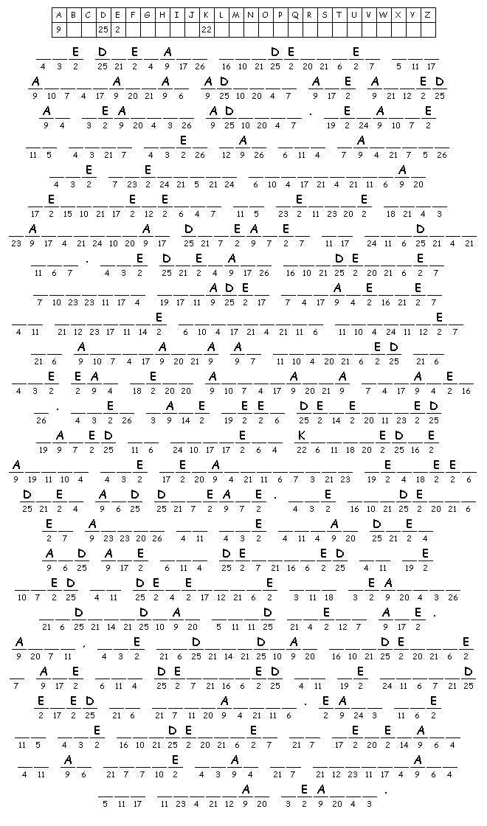
Answer
The Dietary Guidelines for Australian Adults are aimed at healthy adults. Because of this they may not satisfy the specific nutritional requirements of people with particular diseases or conditions. The Dietary Guidelines support broader strategies to improve nutrition outcomes in Australia as outlined in the Eat Well Australia strategy. They have been developed based on current knowledge about the relationship between diet and disease. The guidelines apply to the total diet and are not designed to be used to determine how healthy individual food items are. Also, the individual guidelines are not designed to be considered in isolation. Each one of the guidelines is relevant to an issue that is important for optimal health.

Chapter 6: The Australian healthcare system
Activity sheet 1 – Crossword
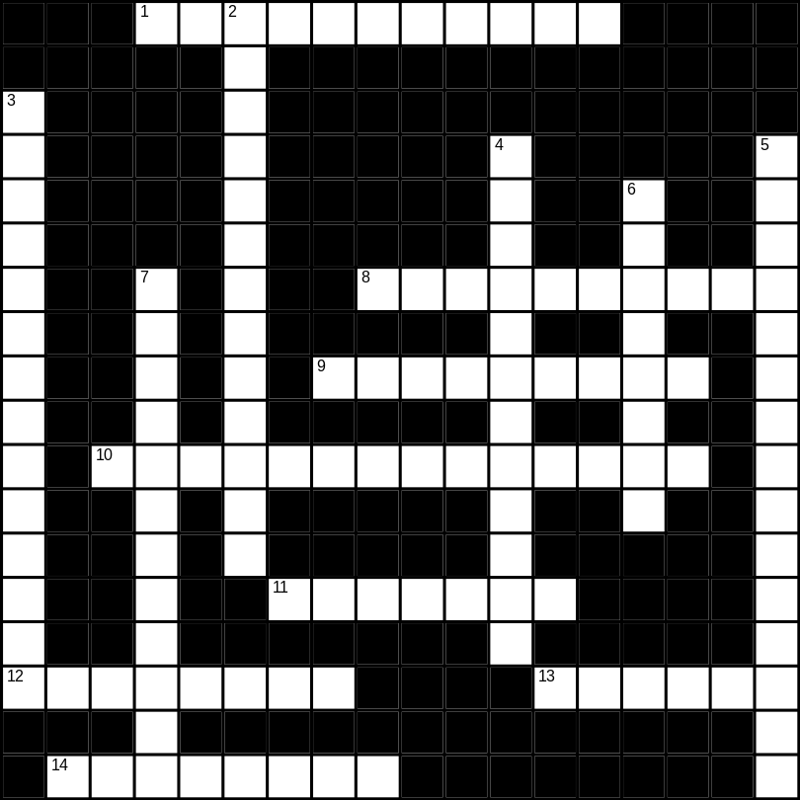
Across
1 The approach to health that is based on an understanding that social and environmental factors have a significant influence on health and has had a significant impact on the development of the Ottawa Charter (6, 5 letters)
8 The approach also known as the fix-it approach to health (10 letters)
9 __________ prevention focuses on detecting and treating illness at the earliest time possible (9 letters)
10 __________ __________ services, element of the Ottawa Charter (8, 6 letters)
11 The name of the declaration of primary healthcare (4, 3 letters)
12 __________ Australia’s government-funded healthcare system (8 letters)
13 The sixth NHPA (6 letters)
14 __________ supportive environments is another element of the Ottawa Charter (8 letters)

Down
2 The second NHPA (6, 7 letters)
3 A period of __________ __________ was introduced to address hazardous living conditions (8, 6 letters)
4 Level of government that contributes most of the funding for healthcare (12 letters)
5 One of the main responsibilities of the state and territory governments in healthcare is the provision of these (6, 9 letters)
6 What the P stands for in NHPA (8 letters)
7 Only about 5% of the governments healthcare budget is spent on this type of healthcare (12 letters)
Answers
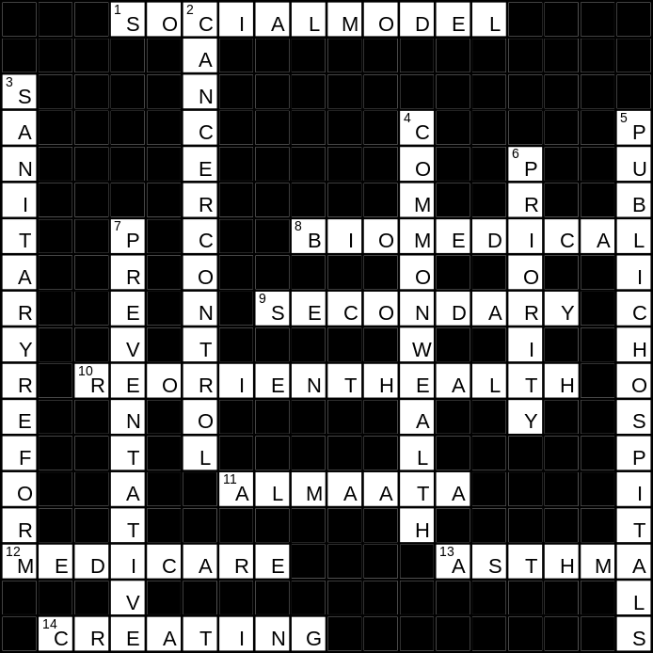
Chapter 6: The Australian healthcare system
Activity sheet 2 – Media analysis
Cancer Council welcomes decision to fund cervical cancer vaccine
The Cancer Council Australia has welcomed today’s announcement that the Australian Government will fund the world-first cervical cancer vaccine under the National Immunisation Program.
Chief Executive Officer of The Cancer Council Australia, Professor Ian Olver, said the decision was an exciting development for future generations of Australian women.
‘The funding of the vaccine will have positive health implications for Australian women in the future and we are extremely pleased the Australian Government has reached a funding arrangement with the vaccine’s maker,’ Professor Olver said. ‘The vaccines’ impact on Indigenous communities will be most beneficial, as the rates of cervical cancer in this population are up to three times as high as the non-Indigenous population.’
Prime Minister John Howard and Health Minister Tony Abbott announced this morning that the vaccine would be available to girls aged 12–13 years from 2007 and a two-year catch-up program will be available to girls aged 13–18 years through schools. In addition, women aged 18–26 years will be able to access the funded vaccine through their general practitioners.
Pioneered by Australian of the Year, Professor Ian Frazer, the vaccine protects against two strains of the human papilloma virus, which cause 70% of cervical cancers. Each year 735 Australian women are diagnosed with cervical cancer and nearly 300 lose their lives to the disease.
‘Australia’s cervical screening program is one of the best in the world and it will remain important for all women as the vaccine does not protect against all strains of HPV,’ Professor Olver explained. ‘The vaccine is not a replacement for the Pap screening program. The Pap smear program has been highly successful in reducing deaths from cancer of the cervix and the vaccine will improve that.
‘The current screening program is still the best protection from cervical cancer for women who have ever sex and they should continue to have their two-yearly Pap smears.’
Source: Cancer Council of Australia, media release, 29 November 2006
Questions
1 Which of the NHPA is discussed in the article?

2 Suggest reasons why Indigenous women are more at risk of cervical cancer than other Australian women.

3 Discuss whether these vaccinations are an example of biomedical or preventative healthcare.

4 Discuss whether Pap smears are an example of biomedical or preventative healthcare.

5 Explain why women are encouraged to still have a Pap smear every two years.

Chapter 7: Understanding human development
Activity sheet 1 – Crossword
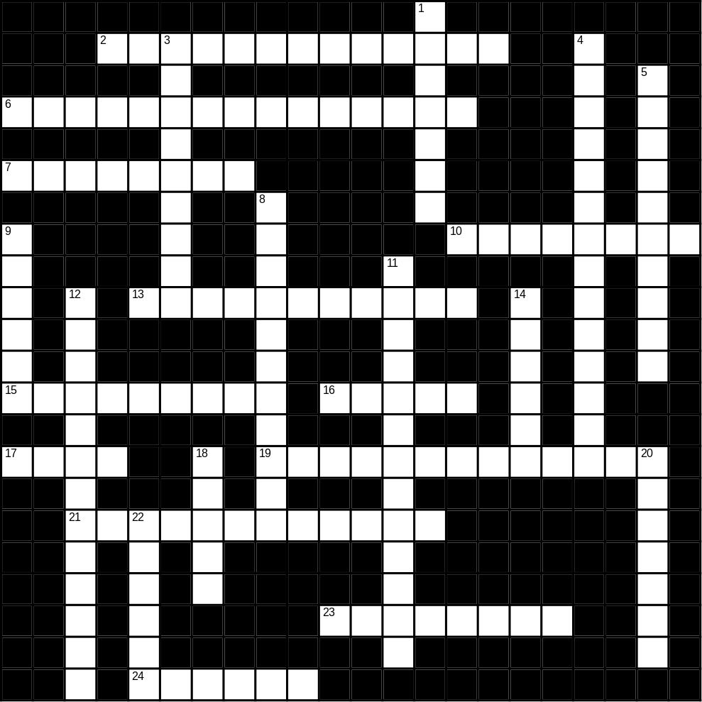
Across
2 The process of acquiring values, attitudes and behaviours through interacting with others (13 letters)
6 The specialisation of cells in order for them to be able to perform specific roles within the body (15 letters)
7 An example of a gross motor skill (8 letters)
10 The body system responsible for its basic structure (8 letters)
13 Describes the gradual changes in an individual’s physical, social, emotional and intellectual abilities (11 letters)
15 The name of a stage during the prenatal period (9 letters)
16 A major organ in the circulatory system (5 letters)
17 Threading a needle requires the use of this type of motor skill (4 letters)
19 Responsible for the transmission of impulses to all parts of the body (7, 6 letters)
21 A type of development where an individual’s ability to think and reason gradually change (12 letters)
23 The acquisition (or modification) of behaviours, usually through interaction with the environment (8 letters)
24 Change mainly due to an increase in the number and size of the body’s cells. This type of change is usually measurable (6 letters)

Down
1 The process of somatic cell reproduction (7 letters)
3 A type of connective tissue (9 letters)
4 Health and development are closely linked. Therefore, they are considered __________ (14 letters)
5 The process whereby an individual gradually realises their genetic potential (10 letters)
8 One of the major periods of rapid growth during the lifespan (11 letters)
9 Proximodistal growth occurs from the __________ of the body outwards (6 letters)
11 The type of growth that occurs from top to bottom (13 letters)
12 The gas expelled as a part of the process of respiration (6, 7 letters)
14 A major socialisation agent, particularly during the earlier stages of the lifespan (6 letters)
18 The building blocks of the structural and functional parts of the body (5 letters)
20 The process used to produce gametes (7 letters)
22 Individual differences in development include those in both its rate and __________ (6 letters)

Answers
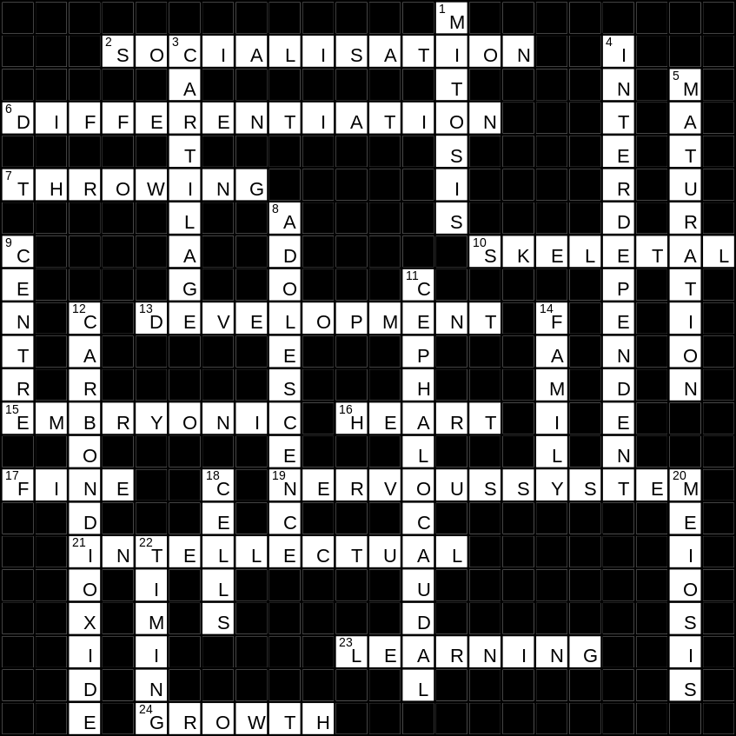
Chapter 7: Understanding human development
Activity sheet 2 – Word search
- Try to find all the words in this list.

bone
cells
* cephalocaudal
change
connective tissue
* development
differentiation
digestive system
emotion
feelings
function
growth spurt
health
intellect
interaction
interrelationships
* motor skills
nervous system
pattern
play
predictable
* proximodistal
* qualitative
* quantitative
skin
socialisation
structure

L | S | Y | C | E | L | L | S | P | M | Q | K | S | L | N | O | N | V | V | L | E
Y | Q | Y | M | T | Y | G | Z | C | E | M | O | T | O | R | S | K | I | L | L | S
M | O | M | O | C | N | L | C | Q | U | A | L | I | T | A | T | I | V | E | Y | D
H | L | F | R | I | C | W | X | P | A | T | T | E | R | N | O | D | Q | A | T | H
D | X | T | L | B | G | C | C | C | H | A | N | G | E | X | B | Z | L | R | P | T
I | C | E | V | W | J | O | Z | U | I | R | E | K | Z | X | M | P | U | V | N | A
O | E | U | Y | E | D | N | U | T | C | V | N | H | S | B | D | P | N | E | N | M
F | X | Q | I | U | B | N | N | I | J | L | N | L | P | V | S | O | M | F | E | P
I | N | T | E | R | R | E | L | A | T | I | O | N | S | H | I | P | S | T | R | R
O | T | L | Z | F | R | C | U | N | K | Y | E | E | T | T | O | Y | S | E | V | O
F | S | G | M | E | G | T | O | S | H | V | L | W | C | L | T | Y | H | M | O | X
D | P | F | F | Z | Y | I | J | Z | I | B | O | A | E | C | S | T | J | O | U | I
Y | S | F | O | N | T | V | D | T | A | R | R | V | E | E | L | O | M | T | S | M
R | I | L | P | C | C | E | A | T | G | E | E | L | V | A | I | N | I | I | S | O
D | W | X | N | V | B | T | C | O | T | D | L | I | E | B | H | P | Q | O | Y | D
O | Y | U | E | J | I | I | T | N | U | E | T | H | V | F | Y | E | Z | N | S | I
I | F | N | T | T | D | S | I | B | T | S | T | R | U | C | T | U | R | E | T | S
H | O | G | N | E | K | S | U | N | E | B | T | F | G | O | S | J | U | E | E | T
B | M | A | R | S | K | U | I | G | Q | I | S | Y | S | E | C | C | Z | D | M | A
K | U | P | X | V | F | E | I | C | E | P | H | A | L | O | C | A | U | D | A | L
Q | A | W | Z | U | L | D | S | O | C | I | A | L | I | S | A | T | I | O | N | Y

- Provide a definition for those terms identified with an asterisk above.
Answers

Chapter 8: Characteristics of development: Prenatal
Activity sheet 1 – Key terms
1 The table below contains key terms relating to prenatal development that have been chopped in half. Find the pieces that fit together and write them in the answer area below.
yonic | Plac | ogens | um
Respi | nate | Refl | Circu
Adapt | Pren | Organo | ntiation
Germ | lical | Sp | exes
Ute | genesis | rus | ations
gar | Conce | Embr | Deoxyg
Umbi | Oxyge | Ov | nated
tal | Fonta | inal | Implan
ration | enta | atal | rature
Terat | lation | Neo | Tempe
Excr | tation | nelles | Dige
stion | Ap | enated | Differe
etion | Foe | ption | erm

2 Select 10 of these terms and write a definition for each of them.
a
b
c
d
e
f
g
h
i
j
Answers
Ovum | Sperm | Germinal | Embryonic
Foetal | Conception | Prenatal | Placenta
Implantation | Umbilical | Uterus | Teratogens
Organogenesis | Differentiation | Fontanelles | Apgar
Neonate | Adaptations | Reflexes | Circulation
Respiration | Oxygenated | Deoxygenated | Temperature
Digestion | Excretion

Chapter 8: Characteristics of development: Prenatal
Activity sheet 2
1 Use a diagram to explain the process of conception.

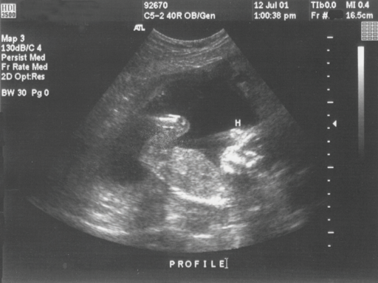
2 Above is an ultrasound image for a foetus at 14 weeks gestation. Although it would be unable to survive if born at this stage of pregnancy, all of the major organs have been formed.
a Outline the development that has preceded this 14 week milestone in both the germinal and embryonic stages.
Germinal:

Embryonic:

b Outline the development that will occur during the remaining 26 weeks of pregnancy.

- The placenta is vital to the survival of the foetus until it is born. Explain what the placenta is and what its main functions are.

- Immediately after birth the baby will have to make several adaptations to adjust to his or her new environment. Outline these adaptations and explain why they are needed.

Fill the gap
a Female gametes are called ____________ and male gametes are called ___________.
b At conception the newly formed individual contains ____ chromosomes.
c When calculated from the first day of a woman’s last period the full term pregnancy is said to be ______ weeks.
d After the first cell division the developing individual is referred to as a __________.
e After about four days the developing individual contains about 32 cells and is referred to as a ______________.
f Once the cells begin to differentiate to form key structures the developing individual is referred to as a ______________.
g The lining of the uterus where implantation occurs is called the _________________.
h The ___________stage of pregnancy lasts from conception to the end of week 2.
i The ____________ stage of pregnancy lasts from the end of week 2 until the end of week 8.
j The ___________ stage of pregnancy lasts from end of week 8 until birth.
k The name of the first hormone produced by the placenta is ______________.
l Most structures and body systems are established during the _____________ stage of pregnancy.
m Factors that may have a negative impact on the development of the developing individual during pregnancy are called _____________.
n The _________ __________ is used to assess a babies functioning after birth.
Chapter 9: Characteristics of development: Infancy to old age
Activity sheet 1 – Fill the gap
Clues
1 The growth rate during infancy is ______________.
2 _________________ charts are used to measure growth patterns during infancy and childhood.
3 _______________ skills refer to the ability control body movements.
4 The main hormone responsible for regulating growth in childhood is __________ hormone.
5 One of the most significant aspects of physical development in adolescence is ________________.
6 The rapid gain in height and weight during adolescence is known as the ____________ __________.
7 The hormone that is responsible for the greater gain in muscle mass in males compared to females is called ____________.
8 Menarche is the name given to a females first ________________.
9 ____________ sexual characteristics are those that are concerned with the functioning of the sex organs.
10 The lining of the uterus is called the _______________.
11 The development of _________________ is an important milestone of emotional development during adolescence.
12 Changes in hormone levels around the age of 50 trigger the onset of _______________ in women.
13 An important characteristic of social development in adulthood is the establishment of a range of new _______________.
14 During late adulthood and old age individuals experience a ___________ in sensory functioning.

Answers
1 Rapid
2 Percentile
3 Motor
4 Growth
5 Puberty
6 Growth spurt
7 Testosterone
8 Menstruation
9 Primary
10 Endometrium
11 Self-concept
12 Menopause
13 Roles

Chapter 9: Characteristics of development: Infancy to old age
Activity sheet 2 – Media analysis
Mental training slows cognitive decline
By Dr Norman Swan
One common problem with medical research is that it often doesn’t actually measure what counts for you and me. Who cares whether some fancy new drug reduces our blood rhubarb levels? We want to know if it makes us live longer healthier.
Dementia research is even more fraught because there are tests of mental function which don’t necessarily translate into extra meaningful brainpower. The thing is though that they’re easier to do than measuring everyday functional abilities like shopping, looking for a phone number or understanding a label.
But now it’s been shown in a trial of several thousand elderly people in reasonable health, that specific 10-session courses in memory, speed of thinking and being able to reason, do improve a person’s performance and seem to last.
A five year follow up has shown that mental training reduced the normal decline in daily functioning with aging, although the reasoning training seemed to make the most difference and increased mental speed needed a booster course to maintain its effect.
Since dementia medications are still fairly pathetic in their effects, here’s a non-drug way to prevent decline in people who are still functioning pretty well.
Source: ABC Health Minutes, 6 February 2007, available at www.abc.net.au/health/minutes/stories/s1841129.htm (accessed 1 May 2007)
Questions
1 Outline examples of intellectual development that may take place during old age.

2 Outline factors that may influence intellectual development during old age.

3 Explain why it may be difficult to measure an individual’s level of mental functioning, especially during old age.

4 Explain how undergoing training courses such as those outlined in the article can assist in promoting health and development during old age.

5 Other than undertaking training courses such as those in the article, discuss steps older people can take to maintain mental function.

6 Justify some tasks that could be used as part of a test to measure an older person’s memory.

7 Explain how preventing mental decline among the elderly could benefit the Australian Government and the healthcare system.

Chapter 10: Genetic influences on health and development
Activity sheet 1 – Fill the gap
Select from the key terms below to fill the gaps. Words may be used more than once.
meiosis, karyotype, hormones, phenotype, genotype, predisposition,
environmental, inherited, sex, ethnicity, genes

1 ______________ and ______________ factors both contribute to variations in development and health status.
2 The process whereby the sex cells are produced is known as ______________.
3 ______________ are the basic units of inheritance that determine ______________ and influence body size and shape, the rate and timing of development, genetic ______________ to disease and longevity.
4 The entire set of genetic material an individual possesses is called their ______________.
5 ______________ are the chemical substances that are produced by the body and regulate growth and the rate and timing of development throughout the lifespan.
6 ______________ refers to the traits and characteristics that are observable.
7 The genetically inherited code for genetically predetermined characteristics that have the potential to be expressed is known as ______________.
8 An individual’s genetic make-up can make them more susceptible to disease and this is known as genetic ______________.
9 ______________ is an example of an ______________ factor that contributes to differences in health status and life expectancy between men and women.
10 ______________ is another ______________ factor that influences physical development such as skin colour and height, but may also place them at greater risk of some diseases.
Chapter 10: Genetic influences on health and development
Activity sheet 2 – Media analysis
Genetic tests taken under pressure, survey finds
By Julie Robotham, Medical Editor / Courtesy of Fairfax
Some people who have been tested for hereditary diseases felt coerced into doing so by family members, insurance companies or mortgage lenders, the first national survey on the issue has found.
One in 15 of those who responded to the survey had had an unwanted gene test – mainly for blood or brain disorders or cancer – under pressure from others, said Kristine Barlow-Stewart, director of the Centre for Genetics Education in the NSW Department of Health.
‘The majority [of pressured cases] were from other family members. People felt pressure to assist another family member, or there was pressure to have a test because it might show something about their own health,’ said Dr Barlow-Stewart, one of the study’s coordinators.
But some had felt pushed into testing because insurance or loans would otherwise be denied to them or would be more expensive based on their family history of inherited disease. If they took the test and it was clear, then underwriters would consider them on normal terms. But people tested in the hope they could show they did not carry a rogue mutation might gain distressing knowledge they were unprepared for.
‘If there is a family history, insurance can be loaded so high the majority can’t afford it,’ Dr Barlow-Stewart said. ‘In some cases [the loading] can be 300%.’ Such financial pressure could push people towards tests.
Insurers are explicitly forbidden from demanding gene tests from applicants, though people who have had such a test may be bound to reveal its results under disclosure rules.
Source: The Sydney Morning Herald, 5 November 2004
Questions
1 Outline the advantages and disadvantages to individuals if they decide to undergo genetic testing.

2 a Explain the term ‘ethical’.

b Do you feel that it is ethical for banks, employers, insurance companies or family members to request access to an individuals genetic information? Justify your response.

c Do you feel that it is more ethical for some groups to request this information than others? Justify your answer.

3 If an individual has undergone genetic testing and is found to be a carrier of a genetic condition, or have the potential to exhibit the characteristics of an inherited disease, do you feel that they have a moral obligation to share this information with anyone else? Explain your answer.

4 Outline the advantages and disadvantages to the community of more individuals deciding to undergo genetic testing.

5 Other than inherited or genetic conditions, there are other inherited factors that will influence health and development. Identify two of these and explain how they can influence health and development.

Chapter 11: Environmental influences on health and development
Activity sheet 1 – Crossword
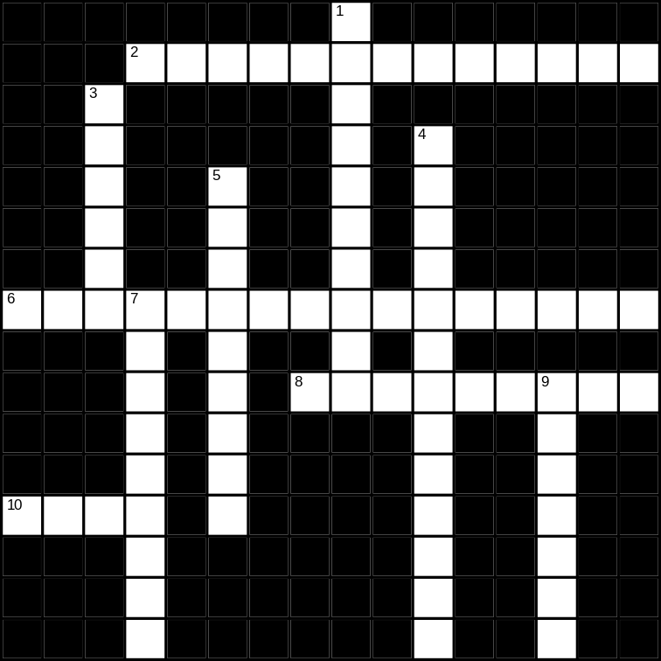
Across
2 Status type used to compare population groups, determined by a combination of income, education level, employment status and occupation type (13 letters)
6 An environmental factor that has an important influence on health, that is also important for the development of motor skills (8, 8 letters)
8 Access to these will influence health, may be human or non-human, and examples include knowledge, services, money and time (9 letters)
10 An environmental factor that plays an important role in influencing health and development; can be a risk or protective factor for disease (4 letters)

Down
1 Access to this is a significant environmental factor that is influenced by knowledge and availability (6, 4 letters)
3 The first and most significant influence on an individual’s socialisation (6 letters)
4 Initially formed within the family and later extending to others in the wider community; are important for social health and development (13 letters)
5 An important environmental factor that provides individuals with the knowledge to make informed decisions in relation to their health (9 letters)
7 A lifestyle that involves little or no physical activity (9 letters)
9 Customs and traditions associated with the society in which a person lives (7 letters)
Answers
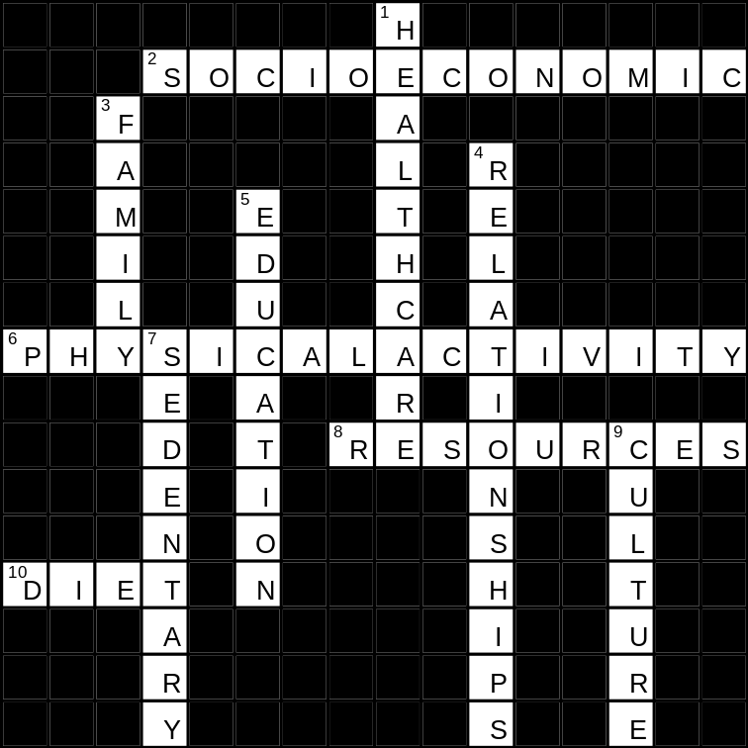
Chapter 11: Environmental influences on health and development
Activity sheet 2 – Media analysis
Fast food ahead of fruit on many teens’ unhealthy menu
By Chee Chee Leung / Courtesy of Fairfax
More than a third of Australian teenagers ‘rarely or never’ eat fruit and one in five have fast food daily, according to a study of young people’s eating habits.
The survey of more than 3800 secondary students found that almost 90% ate ‘extra’, non-essential foods – including fast foods, lollies, crisps and sugary drinks – every day. ‘The average teenager’s diet is a long way from what we would recommend in terms of health and wellbeing,’ Deakin University researcher Professor David Crawford said. ‘The fact that we are seeing an epidemic of obesity isn’t really surprising when you look at these kinds of patterns of eating.’
The survey, by researchers from Deakin’s school of exercise and nutrition sciences, asked year 7 and 9 students from 37 Victorian schools to record their eating patterns. The results showed that almost two thirds did not eat foods from the five recommended food groups daily – although about half ate foods from each group on most days.
The five food groups include bread and cereals, vegetables, fruit, dairy, and meat and meat alternatives.
Young people in regional areas were slightly healthier than their city counterparts, eating vegetables more frequently and fast food less often. One in four in metropolitan Melbourne had fast food every day, compared with one in 10 in regional Victoria.
Girls also tended to have more nutritious diets than boys, eating more fruit and less fast food and sugar-sweetened drinks, although boys ate more meat and meat alternatives. In a paper to be published in the Asia-Pacific Journal of Clinical Nutrition, the researchers say a significant proportion of adolescents have eating habits that are ‘incompatible with their long-term health’. They argue this highlights the need for public health initiatives that encourage teenagers to adopt healthier eating habits.
Dr Andrew Kennedy, clinical leader of the Centre for Adolescent Health at the Royal Children’s Hospital, said many lifelong behaviours – including eating and drinking – were ‘entrenched’ in the teenage years. ‘If they are eating not much fruit, and they are eating fast food … it certainly does predispose to obesity, which in turn predisposes to a variety of diseases, including heart disease and diabetes,’ he said.
The next stage of the research will investigate what influences affect the eating choices of adolescents
WHAT ADOLESCENTS EAT
- More than a third ‘rarely or never’ eat fruit.
- About one in five eat fast foods every day.
- Almost two thirds do not eat foods from the five recommended food groups daily.
- Girls have a healthier diet than boys, except for their lower consumption of meat and meat alternatives.
- Young people outside metropolitan areas eat more vegetables and less fast food than their city counterparts.
Source: The Age, 29 March 2007
Questions
1 Describe how nutrition is an environmental factor in optimising health and development.

2 Outline the major nutritional needs of adolescents.

3 Explain the role of the major nutrients needed in the formation of hard and soft tissue, the formation of blood and the production of energy.

4 Identify five major nutrients found in fruit and vegetables.

5 Describe the results of the survey in the newspaper article.

6 What is the link between the consumption of fruit and vegetables and the incidence of obesity in Australia?

7 What other factors are influencing the food consumption of young people?

8 Why do you think there were differences in the fruit and vegetable consumption of young people in regional areas compared to metropolitan areas, and between males and females?

9 Why is the food consumption behaviours of adolescents described in the article of such concern?

Chapter 12: Comparisons in health status
Activity sheet 1 – Crossword
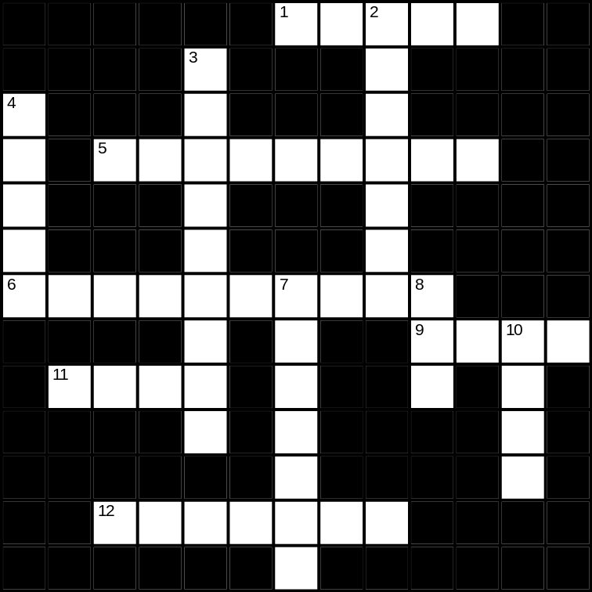
Across
1 Exports and imports are part of international __________ (5 letters)
5 The rate of illness (9 letters)
6 Countries whose economies are not fully developed (10 letters)
9 The amount of life lost due to premature death and ill-health/disability is measured by this (4 letters)
11 International __________ has become a serious concern for many developing countries, and has led to insufficient funds being available for essential services such as healthcare and education (4 letters)
12 Measles, whooping cough and tetanus are examples of diseases that can be prevented using one of these (7 letters)

Down
2 The WHO region that Ethiopia belongs to is called the __________ region (7 letters)
3 The number of deaths is known as the __________ rate (9 letters)
4 Bank that lends money to developing countries to assist them with projects (5 letters)
7 The WHO region Australia belongs to is called the Western __________ region (7 letters)
8 The total value of goods and services produced in a country in a given year (3 letters)
10 __________ expectancy is the number of years a newborn is expected to live, based on the current mortality rates (4 letters)

Answers
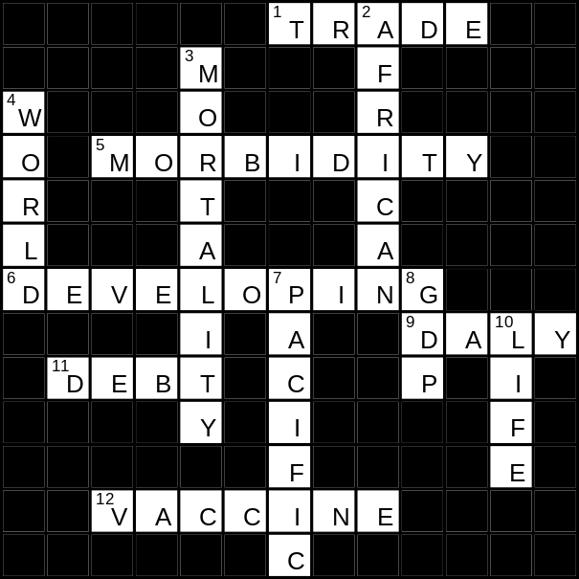
Chapter 12: Comparisons in health status
Activity sheet 2 – Fill the gap
Select from the key terms below to fill the gaps. Words may be used more than once.
adult, child, communicable, debt, developed, developing, five,
healthcare, high, low, non-communicable, three
1 ______________ countries have a higher GDP than ______________ countries.
2 Many developing counties spend more on ______________ to developed countries and the World Bank than they do on essential services such as education and ______________.
3 ______________ diseases are much more common in developing countries than in developed countries, while ______________ diseases are more common in developed countries.
4 The deaths attributed to ______________ diseases is expected to increase in developing countries over the next 20 years.
5 The WHO uses ______________ categories to divide countries, ______________ mortality developing countries, ______________ mortality developing countries and ______________ countries.
6 WHO has divided the member states into ______________ mortality strata on the basis of their level of ______________ and ______________ mortality.
7 Strata B has______________ mortality and ______________ mortality, while strata D has ______________ mortality and ______________ mortality.
8 Countries that are classified as strata level A are considered ______________ while those in strata D and E are considered ______________. Countries in B and C strata are much harder to classify as they may have low mortality but still face a number of barriers to health and economic development.
Chapter 13: Inequalities in global health
Activity sheet 1 – Mind map
Complete a mind map of the factors that contribute to differences in health status and developmental outcomes between Australia and developing countries.
Use the Mind Map ‘Cultural issues for women’ on page 328 of your text and the diagram below to guide you.

Cultural factors

Illiteracy

Lack of access to healthcare and immunisation

Lack of access to safe water and sanitation

Conflict

Poverty

Factors contributing to differences in health status
Chapter 14: Improving global health
Activity sheet 1 – Investigation
Visit the unicef Millennium Development Goals website at www.unicef.org and click on ‘Millennium Development Goals’.
Work in pairs to respond to the following questions. Click on the tabs along the top of the page to select each goal.
1 Identify each of the Millennium Goals.

2 Explain why each of the goals is important in improving health and development.

3 Explain what UNICEF is doing to meet each of the goals.

4 Visit the World Health Organizations Millennium Development Goals website at millenniumindicators.un.org. Investigate and report on the progress of each MDG. Which goals and targets are likely to be met and which are not?

Chapter 14: Improving global health
Activity sheet 2 – Case study
Southern Chad’s drought – Augustin’s story
A worried look spreads over Augustin’s face as his six-year-old daughter, Lea, coughs a chesty cough. ‘When the children are not getting enough food,’ he says, ‘they’re more likely to get sick. They often have diarrhoea. The leaves they’re eating are just not giving them any nutrients.’ Like many farmers in southern Chad, Augustin and his family are struggling to find enough to eat. Last year’s harvests were poor, and now they’re scavenging for wild roots and leaves to supplement their remaining supplies of sorghum, the staple crop here. The amount of sorghum Augustin’s family is eating is not sufficient either, for Augustin’s family of five, eating the recommended 400g of sorghum each per day would mean using up their month’s ration of five kilograms in less than three days.
Like most farmers in Bemangra, Augustin grows cotton and sorghum in his fields, an hour and a half’s walk away. Usually each morning, he and his wife and younger children tend their fields, but now, rather than tending his own field, Augustin is working for other farmers who are slightly better off and able to pay him and other workers a small wage. For four hours’ work, Augustin earns just enough to buy a small amount of food for one family meal. The scarcity of sorghum available at the local weekly market has pushed prices up – a sack of sorghum has risen over 33% in four months.
Augustin says, ‘It’s important for me to work in others’ fields to earn some money. We need to buy food so that we have the strength to work in our own fields. But I know we won’t get a good harvest this year. I’m too weak so I can only do the bare minimum.’
‘In 1990, the harvest was good,’ remembers Chief Celestin, ‘but since then, the rains have been bad, the pressure on the land is heavy, and the soil is poor. We try to keep some of our harvest in reserves, but to do that, we need to have food to start with. There’s nothing to eat at home.’
Villagers share their ideas about how they can defend themselves against the poor harvests. One man explains, ‘The rain is an external factor. That depends on God. But we can work to preserve our environment, by not cutting down trees and trying to keep our land fertile. There’s a plant we can use on our land called Mucuna, which fixes nitrogen in the soil and helps replenish the soil’s fertility.’
To earn a living, nearly every farmer in this region grows cotton, the main cash crop here. Yet people struggle year after year to grow enough food.
Source: World Vision Australia, school resource, www.worldvision.com.au
Questions
1 What health issues are Augustin and his community facing?

2 Explain how globalisation is having an impact on Augustin’s community.

3 Explain how sustainable development could be used to improve the lives of those living in Augustin’s community.

4 Identify the elements of primary healthcare that could help Augustin and his family and explain how each element would be able to help them.

5 Develop a strategy that Augustin and his community could use to improve health and explain why you think it would be successful.

