How to Design Research
In developing a research design, we are concerned with the nature of the knowledge that will be generated. A research design represents the investigator’s plans for obtaining the most accurate answers to identified research questions. It describes the process of research from problem identification to the final write-up and distribution of a paper or report. Figure 1, below, outlines the major steps to be followed in the research design process.
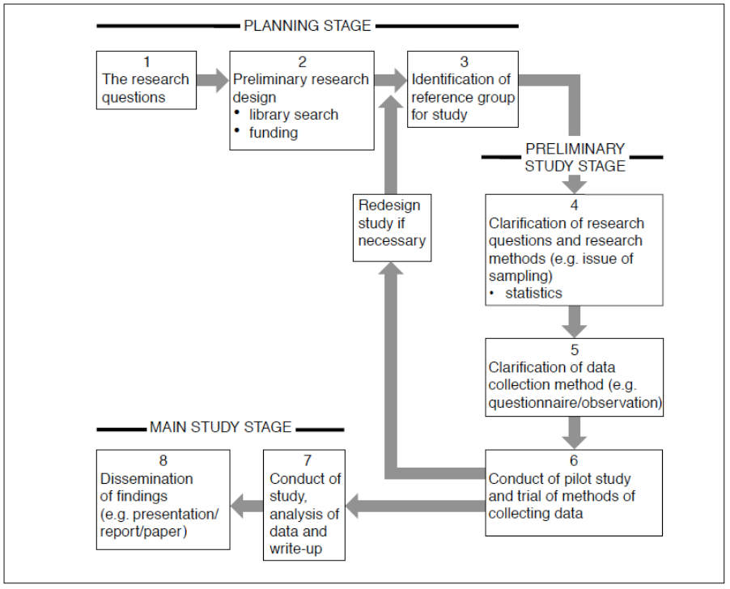
Figure 1: Steps in the research design process

Planning stage
Step 1: The research question(s)
A research design begins with one or more research question(s), which may be suggested in any number of ways, such as through observation or reading. In identifying the broad research questions(s), points to consider include:
- Why am I interested in this research? What are my values and beliefs?
- What will be done with the information generated?
- Who would be interested in participating in the research?
When considering these points, it is a good idea to discuss your research question(s) with colleagues to get another perspective.
Step 2 Preliminary research design
Having made a move towards clarifying the nature of the research question(s), the next stage is usually devoted to fact finding and identification of any research funding available. A literature search should be undertaken to establish current knowledge in the field. This literature review will also provide insight into previous research designs. The results of the literature review and ideas for research design should be discussed with a specialist in the field. Points to consider at this stage include:
- How will the proposed study contribute new knowledge to the field?
- What ‘type’ of knowledge will be generated?
- What is the current state of knowledge in the field?
Step 3 Identification of a reference group
Bearing in mind the research question(s), the researcher must establish who is involved in the study and for whom the research is being conducted. Issues that arise at this stage include:
- the nature of the reference group in the study
- clarification of research questions
- access to the reference group.

Preliminary study stage
Step 4 Clarification of the research method
At this point it is important to clarify the type of knowledge that will be generated in the course of the study. As already indicated, such knowledge may be hypothetical, quantitative, associational or causative. The type of knowledge being sought will play a significant role in shaping the research method, including the nature of the statistical analysis to be used. A review of the literature will help to generate ideas for the research method and analysis of the data.
Step 5: The data collection method
This step includes the following considerations:
- What is the best method of collecting the information needed – questionnaires, interviews, direct observation?
- How can the information collected by these means best be analysed?
- What form will the analysis take?
- How capable is the researcher of undertaking such analysis? Will some consultation be needed?
Step 6: Conducting the pilot study
A necessary step in the research design involves a preliminary run-through of the study, including the procedure and the instruments involved. At the very least, it is necessary to trial questionnaires, interview procedures or observation techniques to identify potential problems, such as children’s ability to understand questions asked of them, the length of time required to administer the questionnaires or any problems with the recording procedures or coding scheme in direct observation. Research findings from the pilot study could be submitted to a group of interested individuals for comment. Various aspects of the research design may be modified as a result of the pilot study.

Main study stage
Step 7: Conducting the main study
After carrying out the previous steps, it should now be possible to complete the major study.
Step 8: Dissemination of the results
The dissemination of the research findings could take a number of forms including:
- a conference presentation
- brief written reports for cooperating organisations, such as schools
- a written paper for a journal.

Further reading
To be read in conjunction with this information on research design are pages in the companion website addressing:
- the ethics of research involving young people
- student voice in research
- interviewing young people.

