Research 17.2

Research the rock edicts and rock pillars of Ashoka the Great and answer the following questions:
1 What was the total number of edicts produced by Ashoka during his reign?

2 Where did he usually place his edicts? Why?

3 What languages were used on the inscriptions? Why?

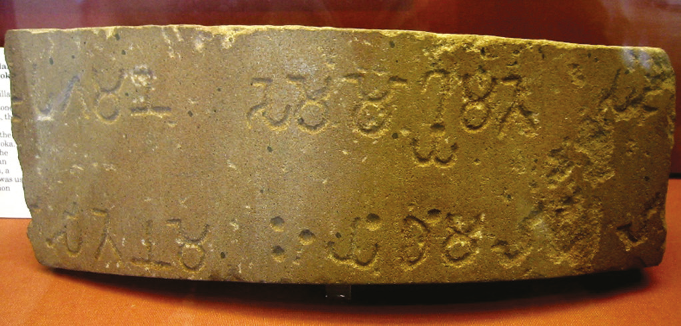
Source 17.20 A remnant of Ashoka’s piller edict

4 Where could you find the actual remnant shown in Source 17.20?

5 Describe the skill and technology required to construct and transport Ashoka’s pillars.

6 Examine the edicts of Ashoka. Do you believe that they were genuine reflections of a Buddhist view of life (religious) or more about the efficient running of his empire and winning over the support of his people (political)? Discuss.

