End-of-chapter questions
Source analysis
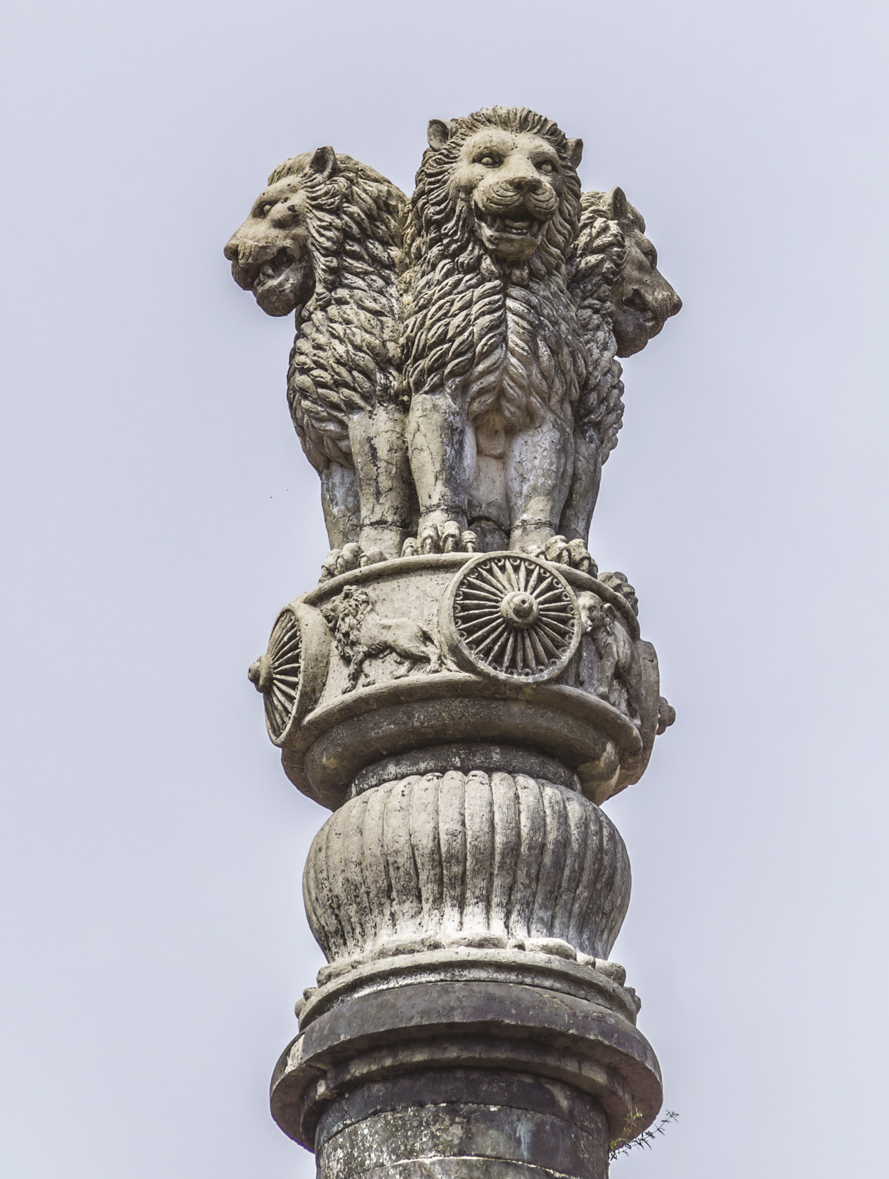
Source 17.2 The national symbol of modern India is based on the Lion Capital, which was
erected by the Emperor Ashoka at Sarnathin 250 BCE. The symbols used by Emperor
Ashoka are evidence of his Buddhist beliefs. Amazing skill and effort were required to
make and transport these columns.

Refer to Source 17.2 and answer the following questions:
1 Ashoka became a Buddhist. What symbols on the capital tell us that?

2 Were columns and pillars the only way in which Ashoka spread his messages?

3 What were his messages called?

4 What were they meant to tell his people?

5 Why might this capital and its symbols have been chosen for modern India?

