End-of-chapter questions
Source analysis
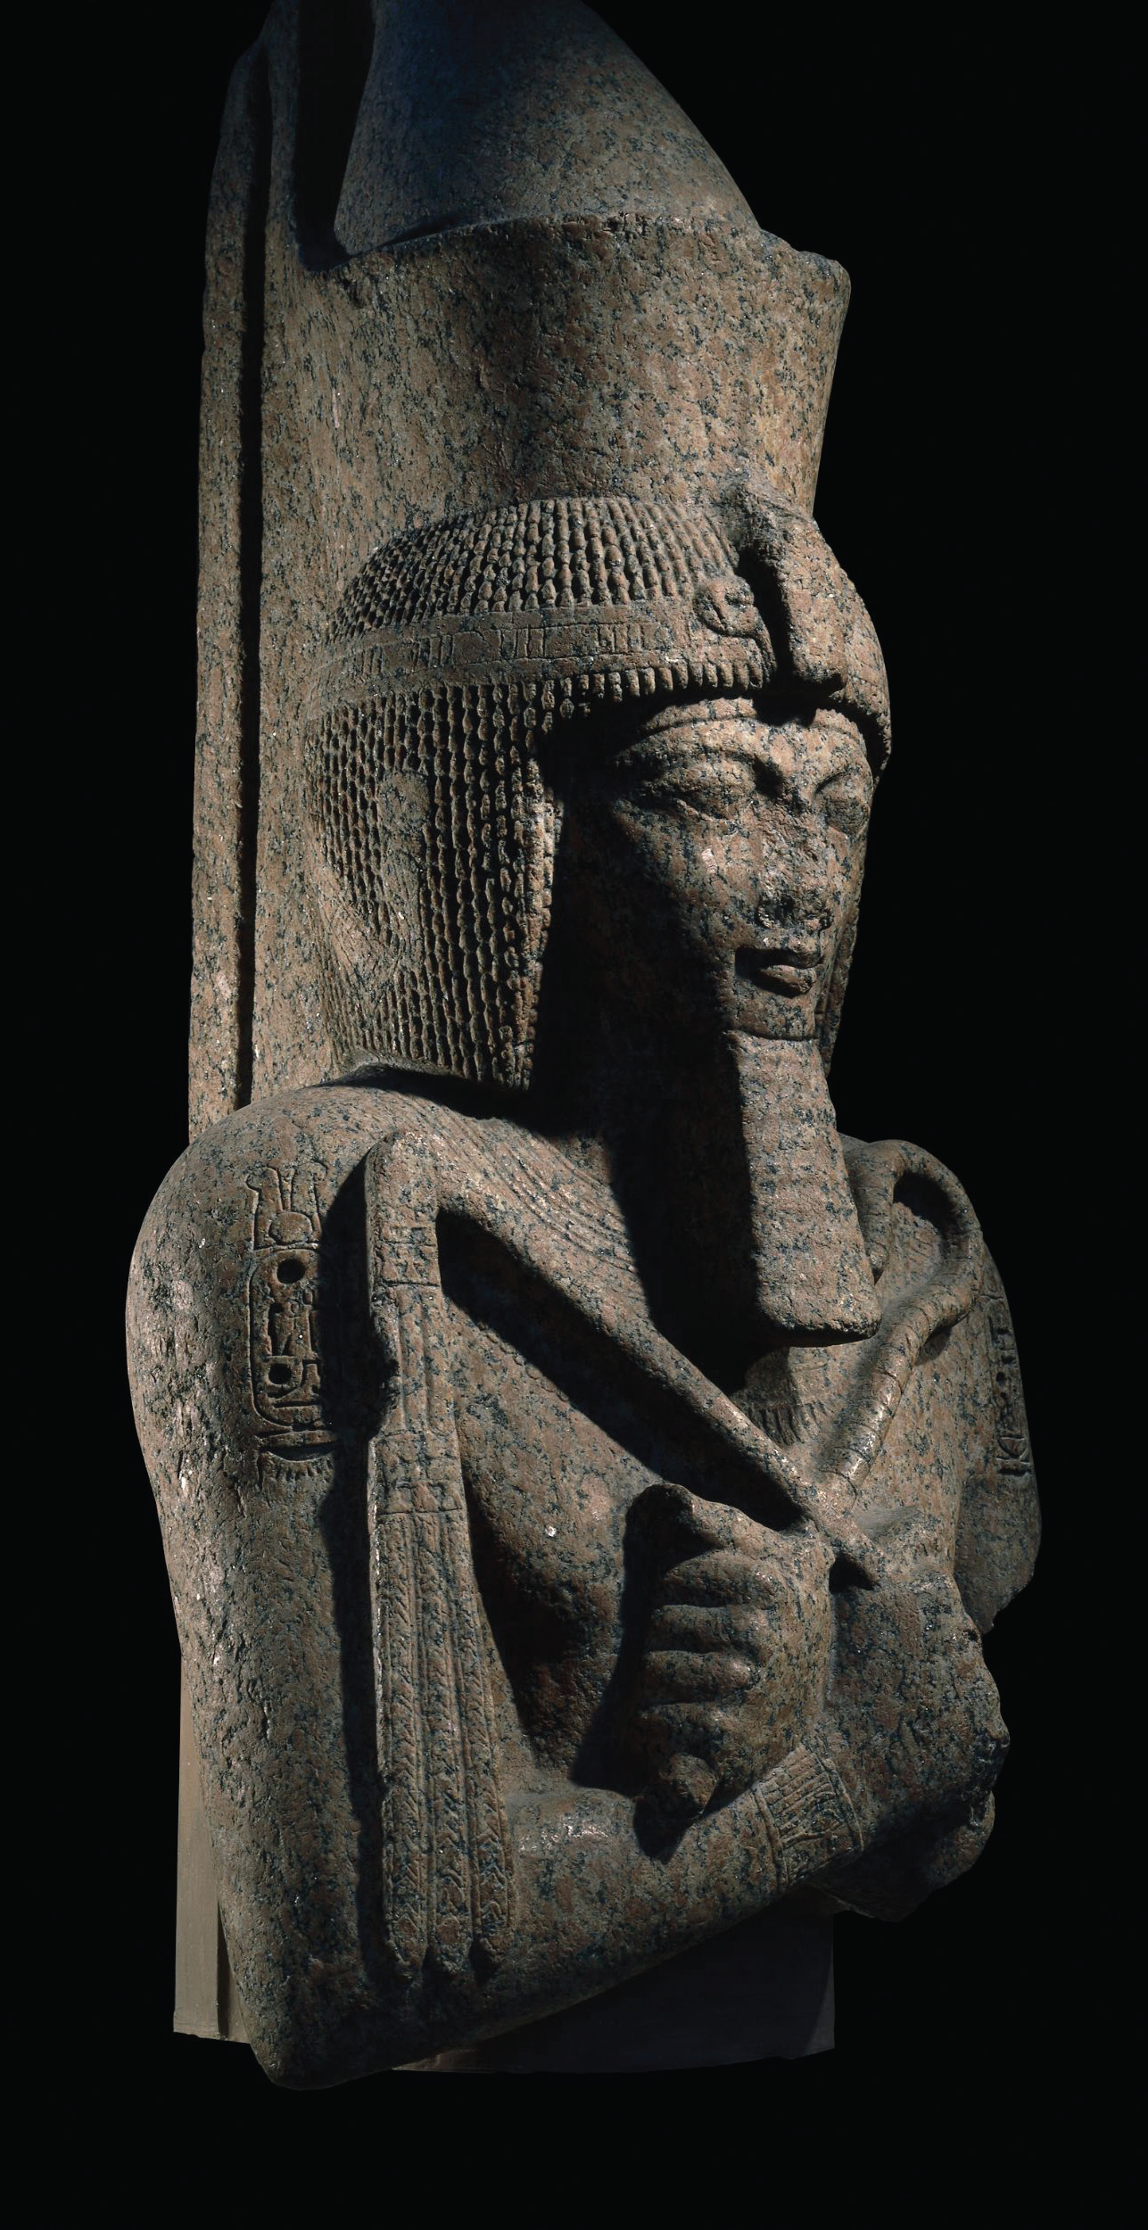
Source 13.22 This granite statue shows the great Rameses II sitting on his throne and holding his symbols of royal authority.

Study Source 13.22 and answer the following questions:
1 Make a list of the symbols of royal authority that you can see on this statue.

2 Why would most Egyptians easily have understood the meaning of the pharaoh’s symbols of the crook and the flail?

3 How was the unification of Upper and Lower Egypt shown in the shape of the pharaoh’s crown?

4 Look carefully at any statues of important people in the area where you live. What sorts of people do we build statues of today?

5 Consider who is the most powerful and important person in Australia today. How does this person show their authority?

