End-of-chapter questions
Extended response

Source 1.11 The goal of sustainability requires that environment, society and the economy are all carefully considered.
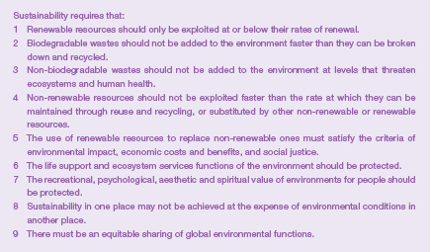
Source 1.14 Sustainability principles

Research the potential environmental, social and economic impacts of the bottled water industry in Australia. With reference to Sources 1.11 and 1.14, assess the sustainability of the industry and present your findings in a short report.

