Developing your understanding 17.6
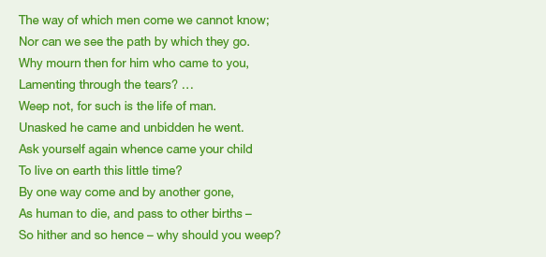
Source 17.16 Thig. VI.1 ‘Pancasata patacara’

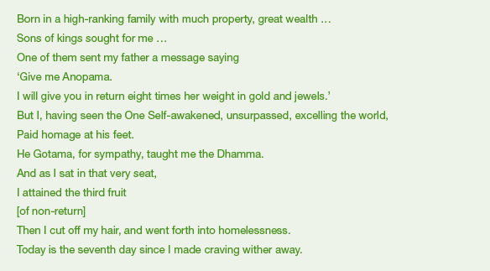
Source 17.17 Thig VI.5 ‘Anopama, the millionaire’s daughter’

Study the two poems in sources 17.16 and 17.17 and answer the following questions:
1 What do they show about the women who wrote them?

2 What do you understand by the following?
• ‘as human to die and pass to other births’
• Dhamma (Dharma)
• ‘non-return’

