Developing your understanding 17.2
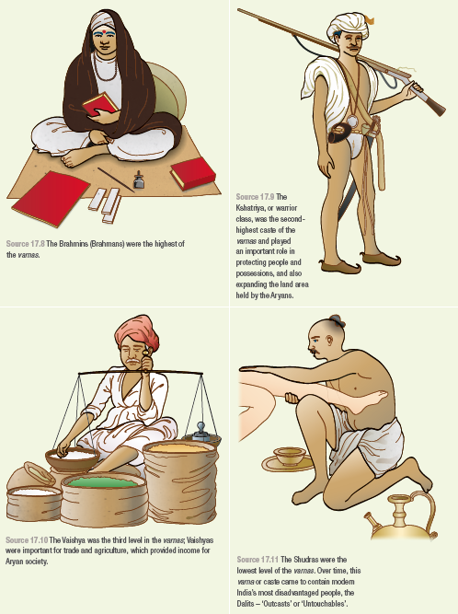

Study Sources 17.8 to 17.11 and summarise the roles of the four different varnas within the Vedic social system.

