Developing your understanding 17.1
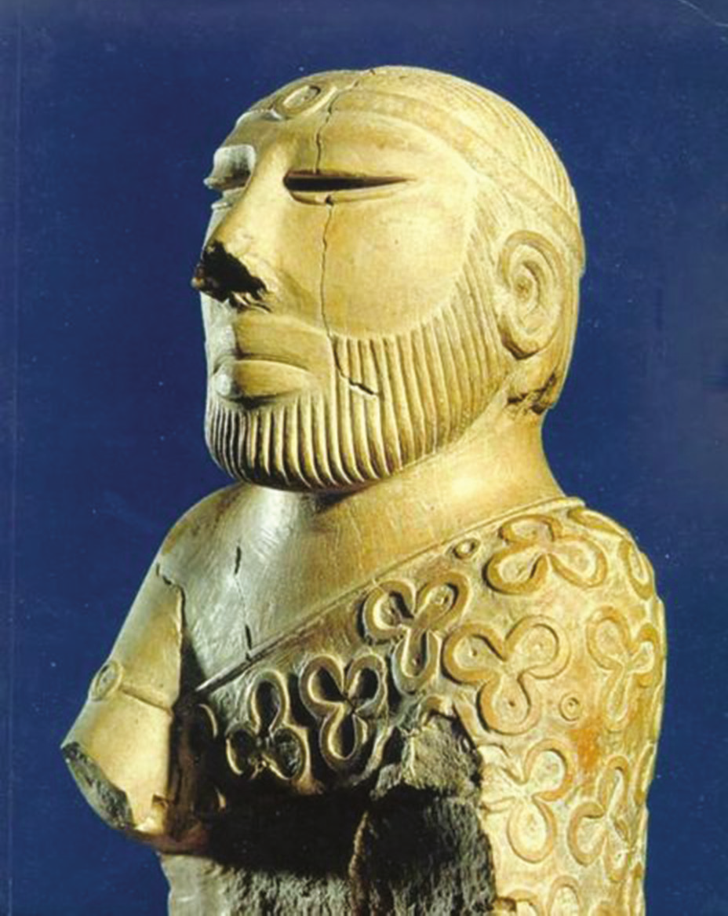
Source 17.5 The Priest-King statuette found at Mohenjo Daro. The
decorations and symbols on the figure, as well as the fine house in which
it was found, suggest that he may have been a leader. Archaeologists
have therefore named him the ‘Priest-King’. The statuette has provided
archaeologists and historians with important clues to the way in which
Harappan society might have been organised.

Study Source 17.5 and answer the following questions:
1 List the features of the statuette that would have led archaeologists to conclude that he played an important role in Harappan society.

2 Some features of the statuette have been lost. Conduct your own research and find out more about these ‘lost features’ of the statuette and the location in which it was found.

3 Explain whether your own findings strengthen the belief that he was important in Harappan society. Provide evidence from your research to support your explanation.

4 Reach your own conclusion on the importance of the ‘Priest-King’ and his role in Harappan society.

