Developing your understanding 15.6

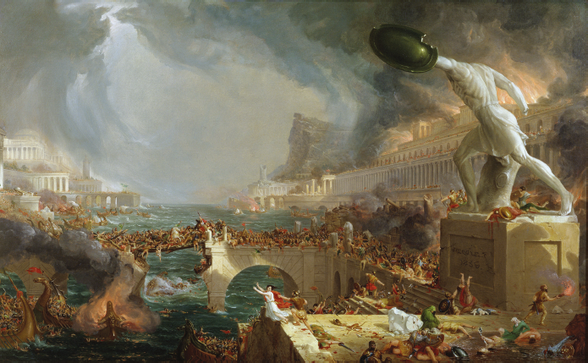
Source 15.15 A painting by Thomas Cole depicting the collapse of Rome

1 Rewrite the caption of Source 15.15.

2 Why do you think the sky is painted with lots of dark clouds and smoke?

3 What do you notice about the large statue on the right-hand side?

4 Find and explain three things that are happening in this painting.

5 Do you think the artist believed that the collapse of Rome was a good thing or not? Explain why you think this.

