Developing your understanding 15.4

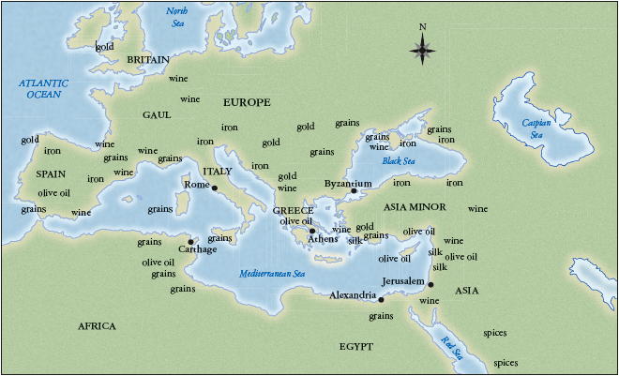
Source 15.12 Ancient Rome’s trade expansion reached from Great Britain all the way down to Africa, covering the entire Mediterranean region.

Look at the map in Source 15.12 closely. Use the details to answer the following questions:
1 List all the items traded with Rome.

2 Which item was traded most?

3 Why do you think this item was so important?

4 Identify the benefits of trading within such a large area.

5 Identify the problems of trading within such a large area.

