Developing your understanding 14.11

1 Greek citizen soldiers were referred to by what term?

2 Explain why they were called this.

3 What was a trireme?

4 Discuss why Darius I invaded Greece in 490 bce.

5 Why did the Athenians expect the Spartans to help them to attack the Persians?

6 How were the Spartans delayed in arriving for the battle at Marathon?

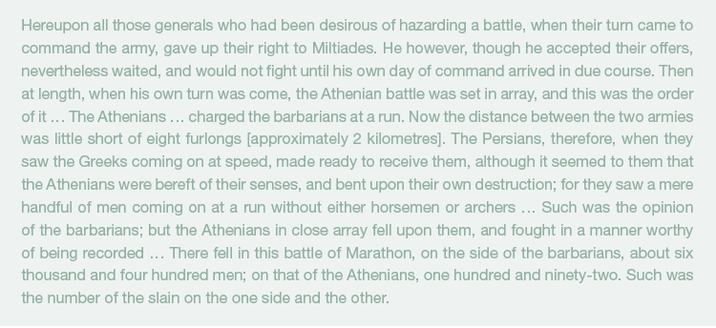
Source 14.17 Herodotus, The Histories, Book 6.110–17

7 Read Source 14.17. It is an Athenian description of the Greeks at Marathon. Is it entirely credible? Do you think it demonstrates any bias?

