Developing your understanding 9.2
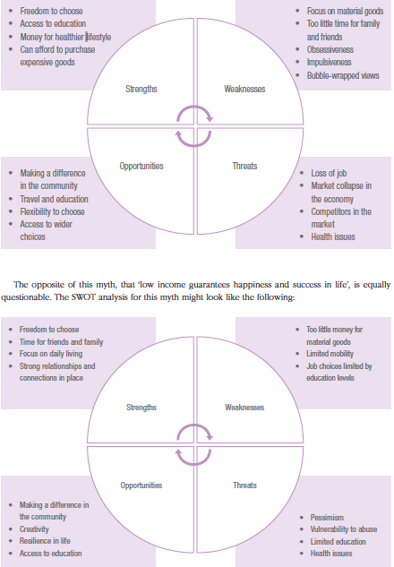

1 What are the similarities and differences between the two SWOT maps above? A discussion of the differences might bring in topics like health and wellbeing and a sense of purpose and optimism about the future, as well as pessimism about issues that cause concern and worry about personal futures. You may also consider how these income differences may affect lifestyles and opportunities in rural, regional and urban locations. After all, what may appear to be examples of living in poverty or affluence can really mean something quite different to the residents.

2 Select one of the ‘myths’ about the liveability of a place that has not already been used as an example and complete the SWOT analysis below.

