Developing your understanding 6.2

1 List some factors that make it easier for settlements to be established.

2 Describe the global trends in settlement patterns.

3 Account for state capitals being located where they are.

4 Explain how remoteness is defined by the Australian Bureau of Statistics.

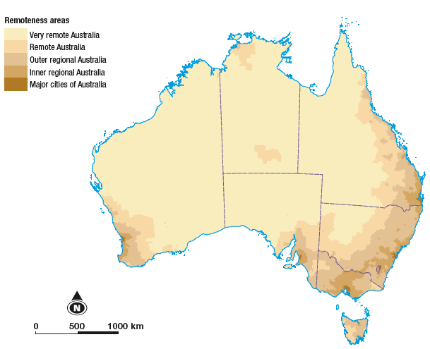
Source 6.3 The ABS 2006 remoteness structure

5 Use the map showing remoteness (Source 6.3) and an atlas to classify the following settlements using the table below.

• Broome | • Katherine | • Cairns
• Cobar | • Dubbo | • Mt Isa
• Rockhampton | • Brisbane | • Launceston
• Bairnsdale | • Coober Pedy | • Mildura
• Tennant Creek | • Wagga Wagga | • Albury
• Yulara | • Charleville | • Canberra
• Freemantle | • Geelong

Highly remote | Remote | Outer regional | Inner regional | Major cities

