Developing your understanding 5.6

1 State the main difference between a tropical cyclone and an east coast low.

2 Find a diagram on the internet that shows how tropical cyclones form. Construct your own annotated sketch of how tropical cyclones form.

3 In which direction do tropical cyclones travel in the Northern Hemisphere – clockwise or anticlockwise? In which direction do they travel in the Southern Hemisphere?

4 Identify the name of the rotational force that causes tropical cyclones to rotate.

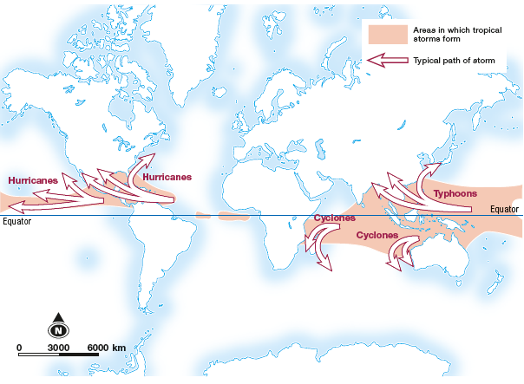
Source 5.7 Tropical cyclones are they are known in different parts of the world

5 Referring to both Source 5.7 and an atlas, write the name used in the countries below to describe tropical storms. The first one has been done for you.
Country | Name
Fiji | Cyclone
USA
Philippines
Japan
Bangladesh
Madagascar
Mexico

6 Explain why tropical cyclones don’t form in Australia’s southern waters, such as off the coast of Victoria.

7 Cyclone Larry struck the Queensland coast in 2006 and destroyed 80–90% of Australia’s banana crop. Reflect on what you think happened to the price of bananas following this event.

