Developing your understanding 5.4
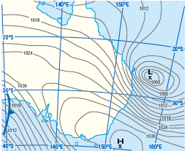
Source 5.5 An east coast low (L) on a weather map

1 On weather maps, areas of equal pressure are indicated by circular lines called isobars. In Source 5.5 an intense low pressure system is indicated by a series of closely spaced isobars that surround the centre of the system. These types of maps are also useful for determining the relative strength of winds across a region. When the isobars are closer together, it indicates stronger winds. When they are further apart, it indicates milder winds. Referring to the weather map in Source 5.5, note the closeness of the lines surrounding the low pressure system off Australia’s east coast. The regions experiencing strong winds can be determined by noting where the lines touch or cross the coast. Using an atlas, identify some of the major towns and cities along Australia’s east coast that would have experienced strong winds and possibly heavy rainfall.

2 Strong winds in low pressure systems like the east coast lows create heavy waves and ocean swells that pummel beaches and other coastal land formations, causing erosion and flooding of low-lying areas. What are some of the hazards that these types of weather systems pose to life and property in coastal areas?

