Developing your understanding 4.4

1 Articulate what is meant by ‘integrated catchment management’.

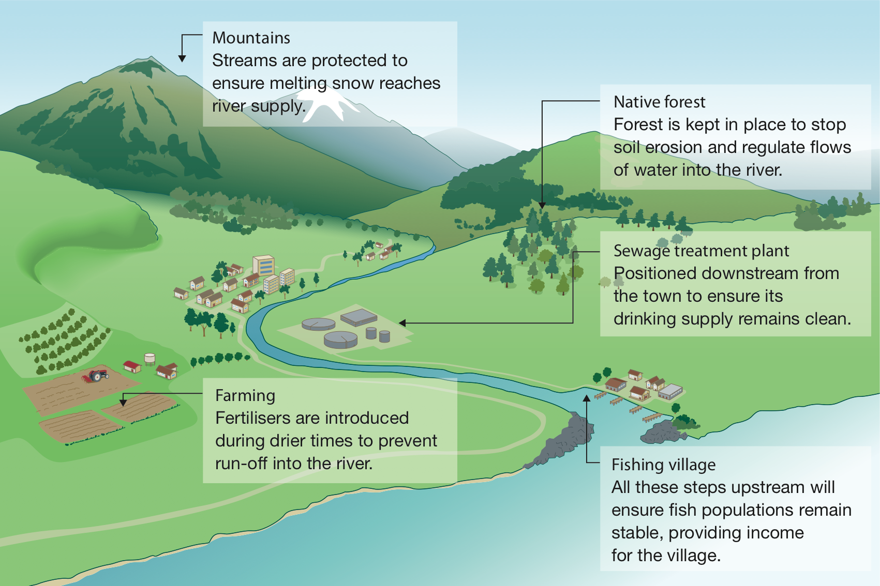
Source 4.15 Integrated catchment management

2 Examine Source 4.15 and refer to key threats to river systems. What would happen to the water if:
a forests were ripped up near the mountains?

b intensive farming took place upstream from the residential areas?

3 Link the causes to the appropriate effects below.

Cause Effect

Introduction of pesticides Algal blooms

Release of fertilisers into the water Fragile ecosystems destroyed

Release of hot water from power stations Poisons entering the food chain

4 Evaluate two benefits of planting native vegetation.

