Developing your understanding 2.2

1 Explain in your own words what ‘run-off’ means.

2 Compare the map of average annual run-off (Source 2.4) to the map of rainfall (Source 2.3). How well do these two characteristics generally compare across the Earth? For example, do areas of higher rainfall normally correlate with areas of higher run-off?

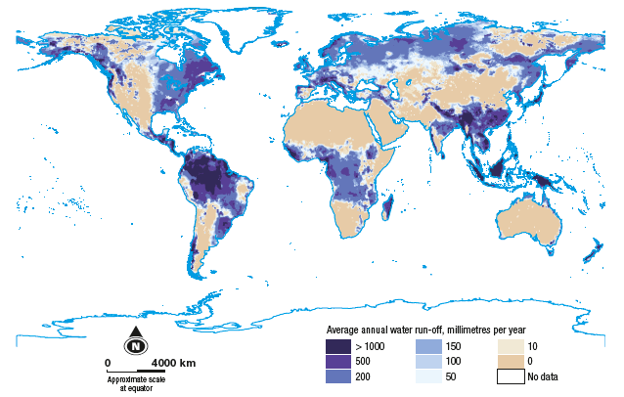
Source 2.4 Average annual run-off by continent and volume

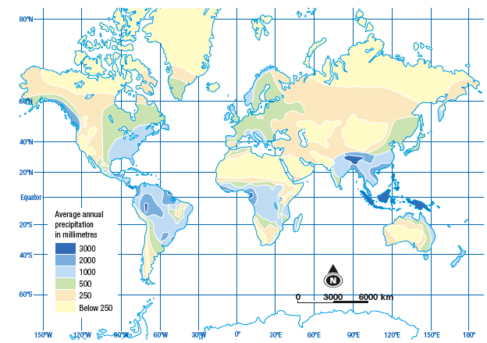
Source 2.3 The average amount of rain that falls around the world each year

3 Using the data from Source 2.4, suggest why Europe has a much lower average volume of run-off than some continents.

4 Locate the following rivers in an atlas or on an online map:
a Amazon
b Mekong
c Nile
d Rhine

