Focus question 11.5
Talk the thought – what makes you say that?
This thinking routine helps convey that the best arguments have strong evidence to support them. Divide into pairs. The first person asks ‘What’s going on in this image?’ (see Source 11.11). The second person responds. The first person then asks, ‘So what do you see that makes you say that?’ The second person then justifies their response using examples from the image.
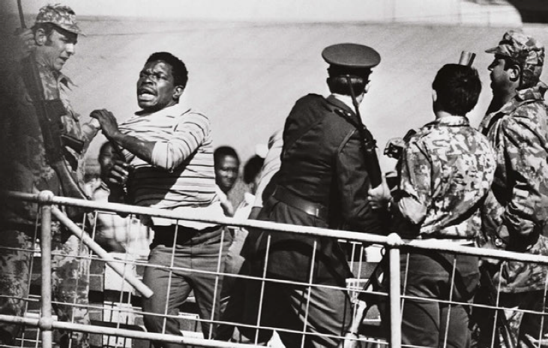
Source 11.11 This photo was taken in Soweto in June 1976

Notes:

