Focus questions 11.3
Talk the thought – what make you say that?
This thinking routine helps convey that the best arguments have strong evidence to support them. The first person asks ‘What’s going on in this image?’ (see Source 11.8). The second person responds. The first person then asks, ‘So what do you see that makes you say that?’ The second person then justifies their response using examples from the image.
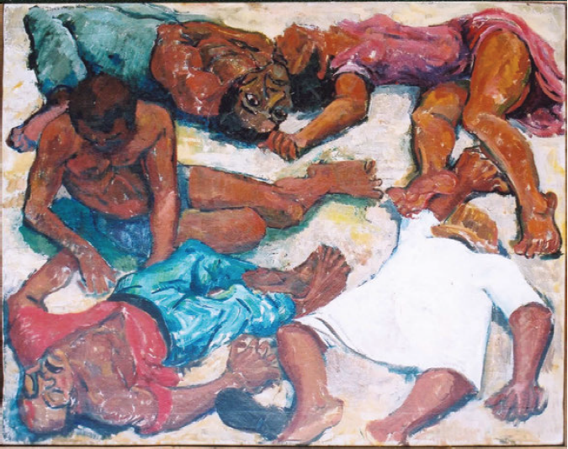Source 11.8 A painting of the Sharpeville Massacre by Godfrey Rubens
Notes:

