Focus questions 8.1
Robert Kennedy was President John F. Kennedy’s brother. His role as Attorney General meant he was also a crucial adviser to the President, and a valuable eyewitness to the events in Cuba. This is his summary of the beginning of the crisis:

On Tuesday morning, 16 October 1962, shortly after 9 o’clock, President Kennedy called and asked me to come to the White House … In his office, he told me that a U-2 [a US spy plane] had just finished a photographic mission and that the intelligence community had become convinced that Russia was placing missiles and atomic weapons in Cuba.

That was the beginning of the Cuban Missile Crisis – a confrontation between the two giant atomic nations, the United States and the Soviet Union, which brought the world to the abyss of nuclear destruction and the end of mankind.
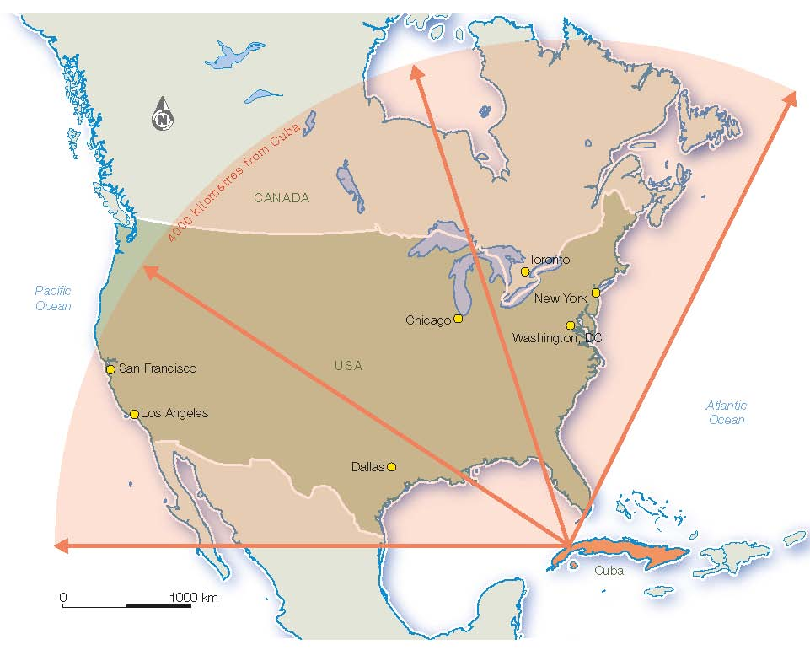
Source 8.1 The cities that could be reached by Soviet missiles from Cuba

- What was the key concern for President Kennedy?

- What was Robert Kennedy’s definition of the Cuban Missile Crisis?

- Use information from the map (see Source 8.1) and extract above to write your own two-sentence summary of what the crisis in Cuba was about.

