Focus questions 5.2
Answer the following questions using information from the graph in Source 5.12 and Chapter 5.
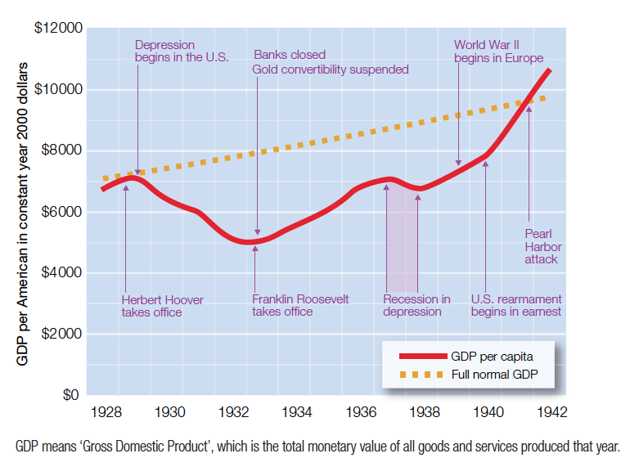
Source 5.12 A graph of America’s economic depression followed by growth

- Who was the President during the depression?

- Why did the economic outlook improve from 1933 onwards?

- What impact did World War II have on America’s economy?

- Use an example from the graph to explain why this might have been the case.

