Analysis activity 16.1: Reading a primary source
Artist Jules Perrin communicates his meaning by the technique of exaggeration, multiplying the number of guillotines far beyond what would ever really have been seen in one place. Perrin suggests, quite correctly, that once a process of Terror is implemented, it tends to gather momentum and to draw in many more victims than intended – often for minor crimes.
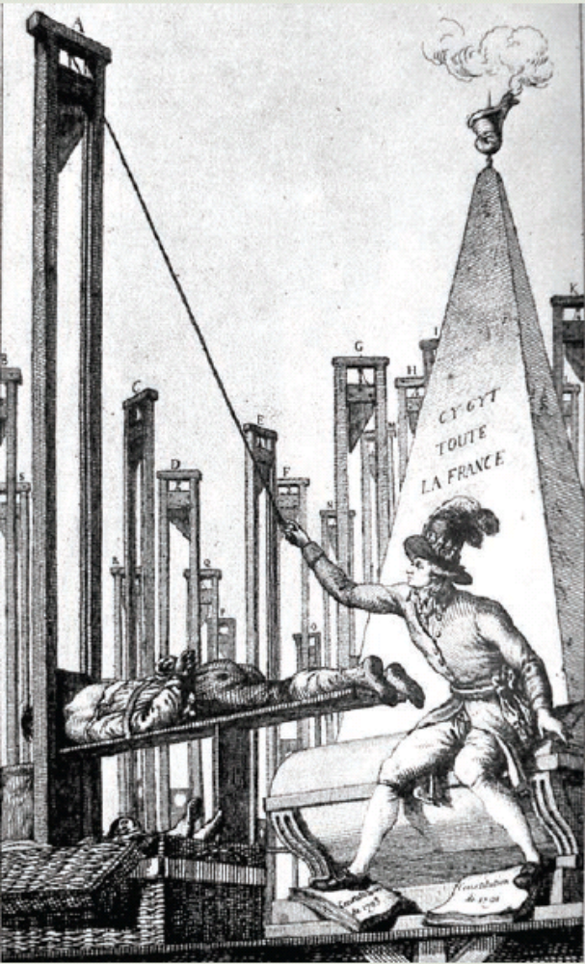
The multiplication of guillotines is visually powerful, but it is reinforced by a textual element that is often omitted when this image is published. Each guillotine is identified by a letter, and these letters are identified in a long caption below the image. They explain the general message with dreadful clarity. We know that ‘a’ represents the guillotine for the executioner (Robespierre) himself, while each other guillotine represents another victim: ‘b’ is the Committee of Public Safety, ‘c’ is the Committee of General Security, ‘d’ is the revolutionary tribunal, ‘e’ is the Jacobins, ‘f’ is the Cordeliers, ‘g’ is the Brissotins, ‘f’ is the Philipotins, ‘k’ is the Chabotins, ‘l’ is the Hébertists, ‘m’ is nobles and priests, ‘n’ is men of talent, ‘o’ is old people, women and children, ‘p’ is soldiers and generals, ‘q’ is constitutional authorities, ‘r’ is the National Convention and ‘s’ is the popular societies. These details are important because they make the nature of the artist’s criticism clear: he is accusing the Jacobins of eliminating virtually every shade of opinion from the political landscape.
Indeed, the image contains even more serious accusations. Robespierre tramples two documents, the Constitutions of 1791 and 1793. The artist therefore alleges that Robespierre and the Jacobins not only suspended the democratic Constitution of 1793, but also destroyed it. Perrin refers to the human cost of the Terror by the individual example of a corpse visible in the wicker basket beneath the guillotine and by a gruesome inscription on the obelisk behind him: ‘Here lies all of France.’
During 1793–94, Perrin’s belief that the Terror would continue to escalate until it killed nearly everybody became widespread, and helped prepare the way for the later dramatic fall of Robespierre. This etching is approximately dated by James Cuno to c. 1793, perhaps because it represents the widespread doubts about the Terror after the end of the war emergency, but before Robespierre’s fall. It is also a critique of Robespierre himself and, according to tradition, Perrin himself went to the guillotine for this attack.

Source 16.7 Robespierre as architect of the Terror
- What is the main criticism of Robespierre being made in this image?

- From your own knowledge of the Terror, how accurate is it to blame the Terror and its victims on Robespierre alone?

