Analysis activity 12.5: Learn from Daqing poster

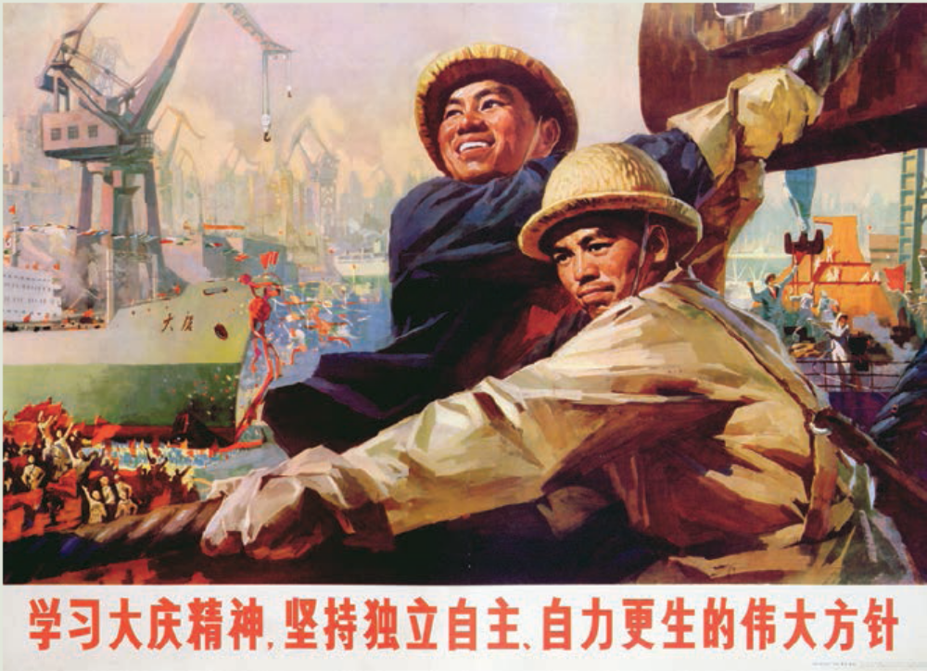

Source 12.10 A ‘Learn from Daqing’ poster

- Identify the ‘heroic’ features of the Daqing workers.

- To what extent did the poster match the reality of the Daqing oilfield?

