Analysis activity 9.2
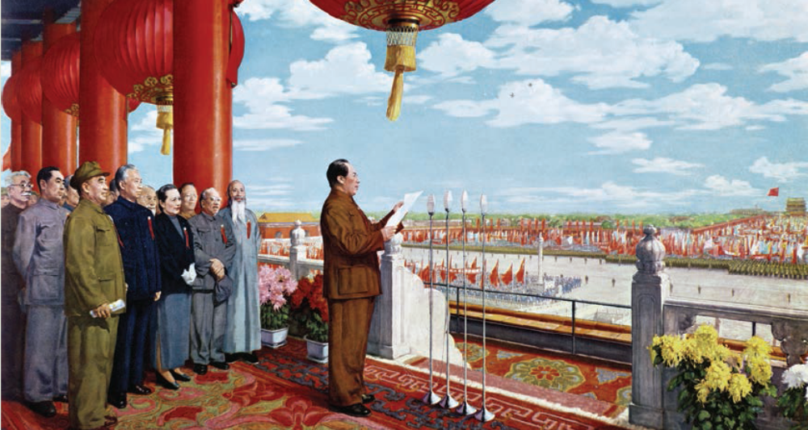

Source 9.6 Mao announces the establishment of the People’s Republic of China, 1949

- Identify those standing with Mao above the Gate of Heavenly Peace.

- To what extent did they help with the revolution?

- What does the painting show about the political relationship of those pictured?

- Using your understanding, discuss how the picture correctly or incorrectly reflects their importance in the revolution and civil war.

