Analysis activity 0.5
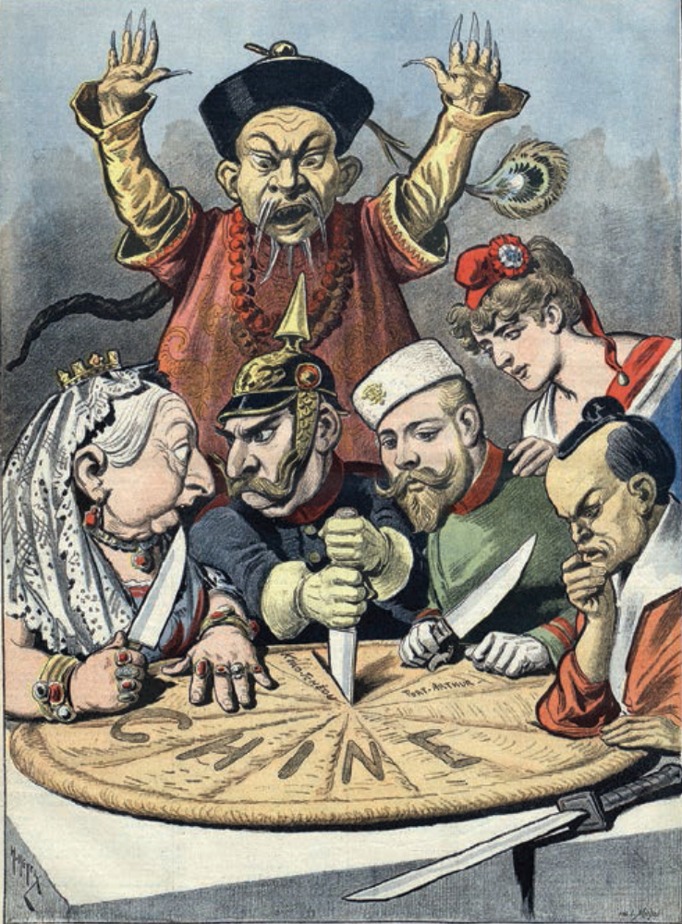

Source 0.27 Political cartoon depicting Imperial China

- Identify which nations are depicted carving up imperial China.

- Identify the features of the cartoon that suggest the events it depicts are taking place during the Qing dynasty.

- Using your own knowledge and the cartoon, explain four means by which China had been humiliated.

- Explain the extent to which this is a reliable view of the foreign presence in China prior to 1911.

