Sample question: Visual analysis
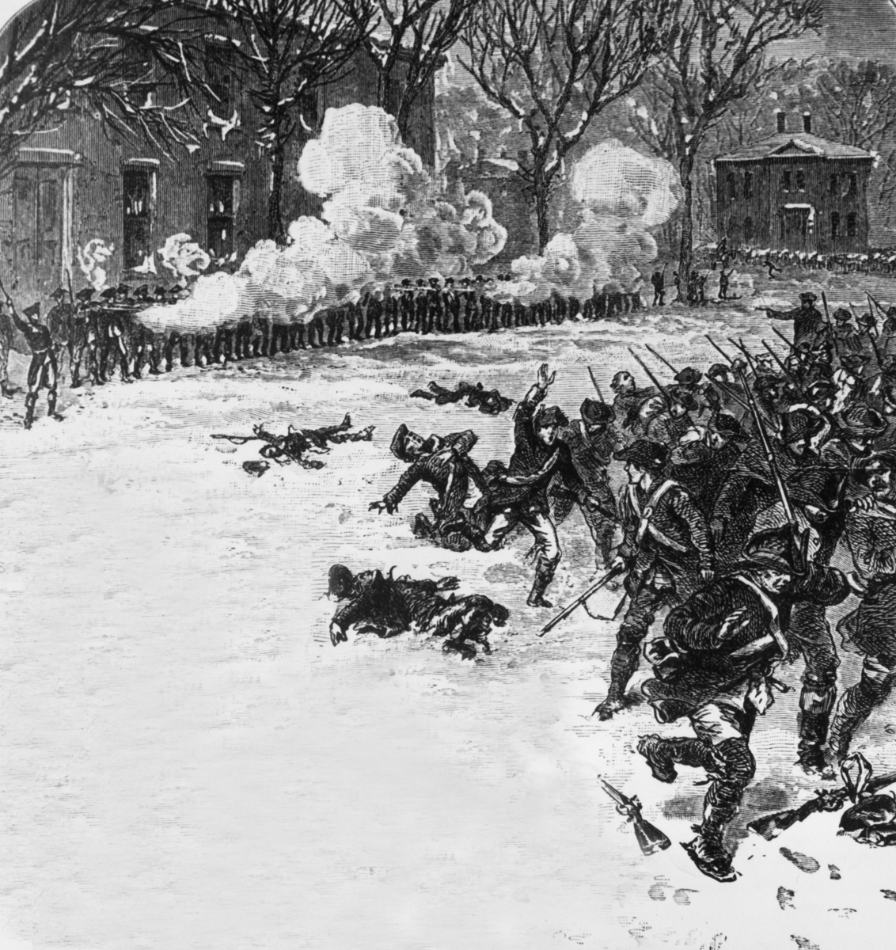

Source 9.5 Image of Shays’ Rebellion being put down by General Lincoln
- Name two groups that are represented in the drawing.

- Name two ways the representation portrays opposition to the Massachusetts Government.

- Using your own knowledge and the document explain the causes of the event depicted in the representation.

- To what extent is this representation useful in understanding the problems within the New Society in 1783–86? Refer to other historians’ views.

