Analysis activity 7.1: Document analysis
The articles of confederation

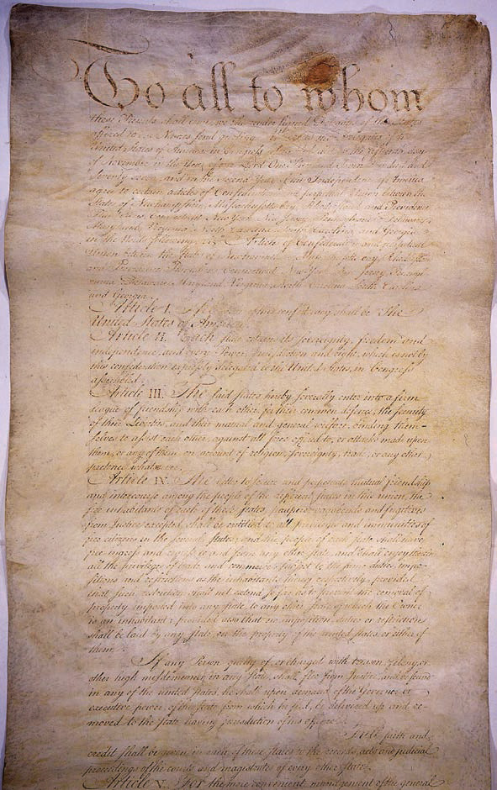

Source 7.10 The first page of the Articles of Confederation and Perpetual Union

The Articles of Confederation and perpetual Union between the states of New Hampshire, Massachusetts Bay, Rhode Island and Providence Plantations, Connecticut, New York, New Jersey, Pennsylvania, Delaware, Maryland, Virginia, North Carolina, South Carolina and Georgia.
Article I. The style of this Confederacy shall be ‘The United States of America’.
Article II. Each state retains its sovereignty, freedom, and independence, and every power, jurisdiction, and right, which is not by this Confederation expressly delegated to the United States, in Congress assembled.
Article III. The said States hereby severally enter into a firm league of friendship with each other, for their common defense, the security of their liberties, and their mutual and general welfare, binding themselves to assist each other, against all force offered to, or attacks made upon them, or any of them, on account of religion, sovereignty, trade, or any other pretense whatever.
Article IV. The better to secure and perpetuate mutual friendship and intercourse among the people of the different States in this Union, the free inhabitants of each of these States – paupers, vagabonds and fugitives from justice excepted – shall be entitled to all privileges and immunities of free citizens in the several States … and shall enjoy therein all the privileges of trade and commerce, subject to the same duties, impositions, and restrictions as the inhabitants thereof respectively … If any person guilty of, or charged with, treason, felony, or other high misdemeanor in any State shall flee from justice, and be found in any of the United States, he shall, upon demand of the Governor or executive power of the State from which he fled, be delivered up and removed to the State having jurisdiction of his offense …
Article V. In determining questions in the United States in Congress assembled, each State shall have one vote. Freedom of speech and debate in Congress shall not be impeached or questioned in any court or place out of Congress, and the members of Congress shall be protected in their persons from arrests or imprisonments, during the time of their going to and from, and attendance on Congress, except for treason, felony, or breach of the peace.
Article VI. No State, without the consent of the United States in Congress assembled, shall send any embassy to, or receive any embassy from, or enter into any conference, agreement, alliance or treaty with any King, Prince or State … No two or more States shall enter into any treaty, confederation or alliance whatever between them, without the consent of the United States in Congress assembled, specifying accurately the purposes for which the same is to be entered into, and how long it shall continue … No vessel of war shall be kept up in time of peace by any State … No State shall engage in any war without the consent of the United States in Congress assembled, unless such State be actually invaded by enemies …
Article IX. The United States in Congress assembled, shall have the sole and exclusive right and power of determining on peace and war, except in the cases mentioned in the sixth article …
Article XII. All bills of credit emitted, monies borrowed, and debts contracted by or under the authority of Congress, before the assembling of the United States, in pursuance of the present confederation, shall be deemed and considered as a charge against the United States, for payment and satisfaction …
Article XIII. Every State shall abide by the determination of the United States in Congress assembled, on all questions which by this confederation are submitted to them. And the Articles of this Confederation shall be inviolably observed by every State, and the Union shall be perpetual; nor shall any alteration at any time hereafter be made in any of them; unless such alteration be agreed to in a Congress of the United States, and be afterwards confirmed by the legislatures of every State.
- List the powers (quoting the source article) that the Articles of Confederation government possessed.

- Explain what the purpose of ‘the firm league of friendship’ was. (Quote and discuss.)

- In whose name would ‘bills of credit … monies borrowed, and debts contracted’ be under? Using your own knowledge and the source (quote), explain why this became such a problem for the New Society.

- Explain what the purpose of Article VI was. What problems did this article try to prevent?

