Analysis activity 6.3: Visual analysis
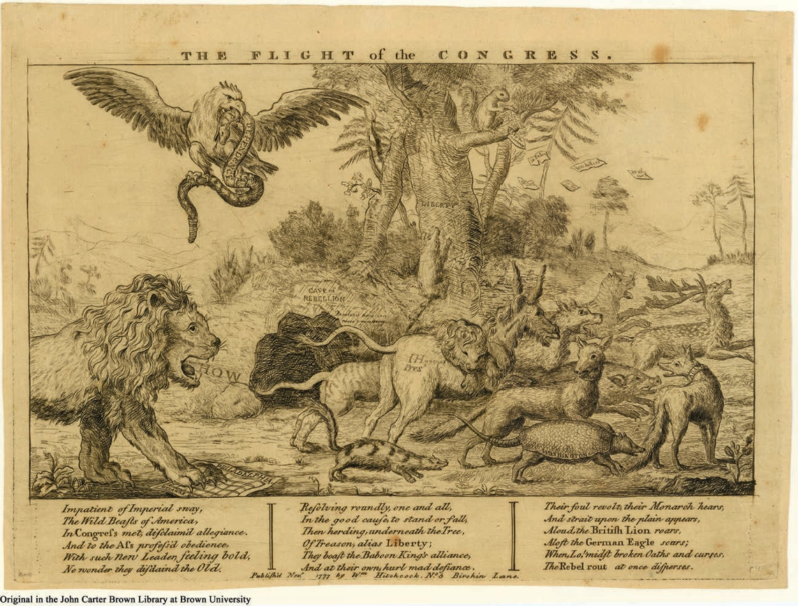

Source 6.15 This example provides excellent insight into some of the symbolism of the era whose meaning will soon change. The Flight of the Congress, Anonymous, London, 1777.

The squirrel: The squirrel up the top of the Liberty Tree throwing paper money down to the Congress is a clever satire, but needs some historical context. The Continental Congress issued paper money after 1775 (called the Continental currency), but the policy on issuing currency was a disaster. Having almost no experience in monetary policy, as well as a desperate need for cash, the Congress ended up printing way too much. Furthermore, individual colonies were not financially regulated and they issued their own money as well. And even the British created counterfeits with their superior press technology and circulated it. So you had hyperinflation, which brought the value down very quickly. And given the perception that America might lose the war, lots of people didn’t want to take Congress-backed money anyway (since it might be worthless in a few years) and preferred gold, silver or pounds sterling. All this caused a lot of instability and hardship in the economy. Often soldiers were being paid in Continentals, only to return from duty and find that their cash was worth only a fraction of its face value in towns and cities. ‘Not worth a continental’ became a popular saying. This squirrel dropping money was put in the cartoon deliberately to appeal to colonists – it was easily one of the most unpopular issues for the Continental Congress. It was also fairly damaging for the Congress’ reputation in foreign financial circles too (from whom they were trying to borrow to finance the war). So liberty is being associated with irresponsibility and uncertainty.
The eagle: The eagle doesn’t refer to America as we know it today – it actually refers to the Imperial Eagle of the Holy Roman Empire, which represents the Germans/Hessians employed by the British.
The snake: The American ‘independence’ is a snake and evidently uncouth and unreliable – an association you could probably make in 1777 but not in today’s world.
The ‘Baboon King’: Some historical context: according to historian John Arbuthnot, in English political satire of the 18th century, Frenchmen were referred to as monkeys, ‘because of his chattering nature and scrawny physique’. By the end of the century, the derogatory label ‘frog’ had developed in its place. Who is the Baboon King?
The armadillo: Washington as an armadillo is quite interesting, and possibly a comment on is Fabian tactics in the early years of the war, hiding and attacking at opportune moments, avoiding open battle with the British
Study Source 6.15 and answer the following questions:
- Explain the viewpoint suggested by the representation (including its accompanying text). Is the creator for or against the Revolution? Why?

- Referring to elements from the representation, what sort of symbols can you identify in the image, and what/who do they represent?

- How does the naming and selection of animals reflect the creator’s political point of view?

- Using elements from the representation and your own knowledge, how does the representation reflect events from the time in which it was created?

