Analysis activity 6.2: Visual analysis

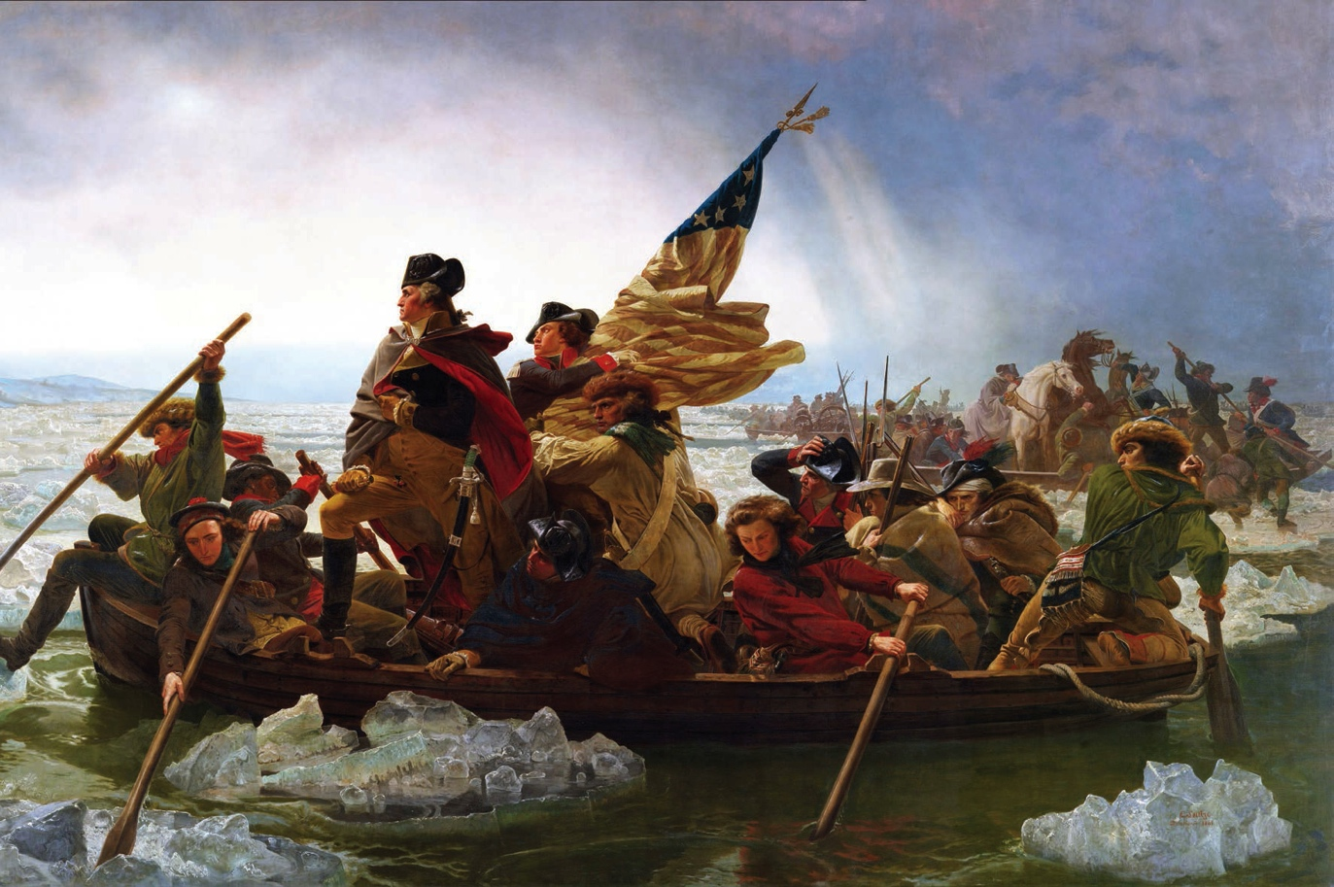

Source 6.10 Washington Crossing the Delaware, by Emanuel Leutze, 1851

Examine Source 6.10 and answer the following questions:
- Can you identify any elements that suggest revolutionary ideals?

- How does the artist represent the importance of Washington’s leadership?

- Using the representation and your own knowledge, explain the events leading up to the crossing of the Delaware and the significance of this event.

- How has the artist depicted and implied that the crossing was not easy?

